CIS430-Lab Assignment 6

Jiahui Wu

ID: 2670210

Object: Trigger and stored procedure

1. Drop all constraints

To avoid conflicts, I dropped all the constraints of table EMPLOYEE and DEPARTMENT, to drop the PK of the two tables, I also dropped some FKs that reference the PK.

1-1. Drop the FK in EMPLOYEE that references PK of DEPARTMENT

/Users/jiahuiwu/Desktop/lab6_2/1-1.png

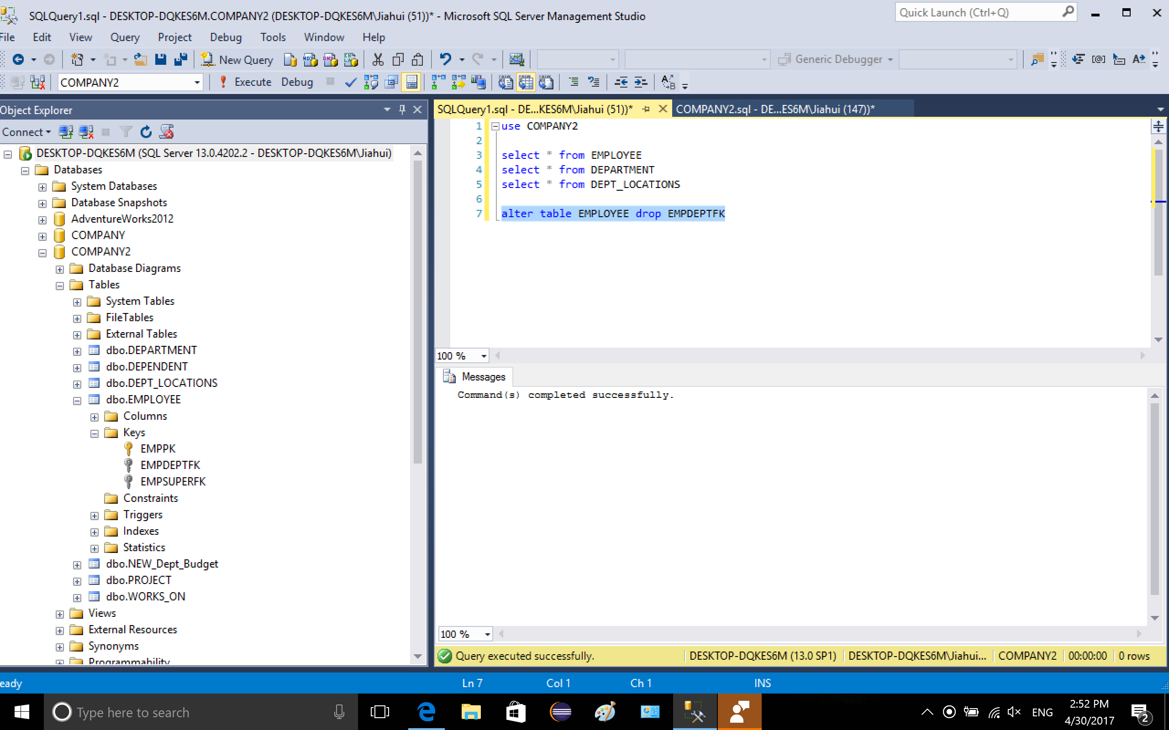

1-2. drop the FK of EMPLOYEE that references the PK of EMPLOYEE

/Users/jiahuiwu/Desktop/lab6_2/2-1.png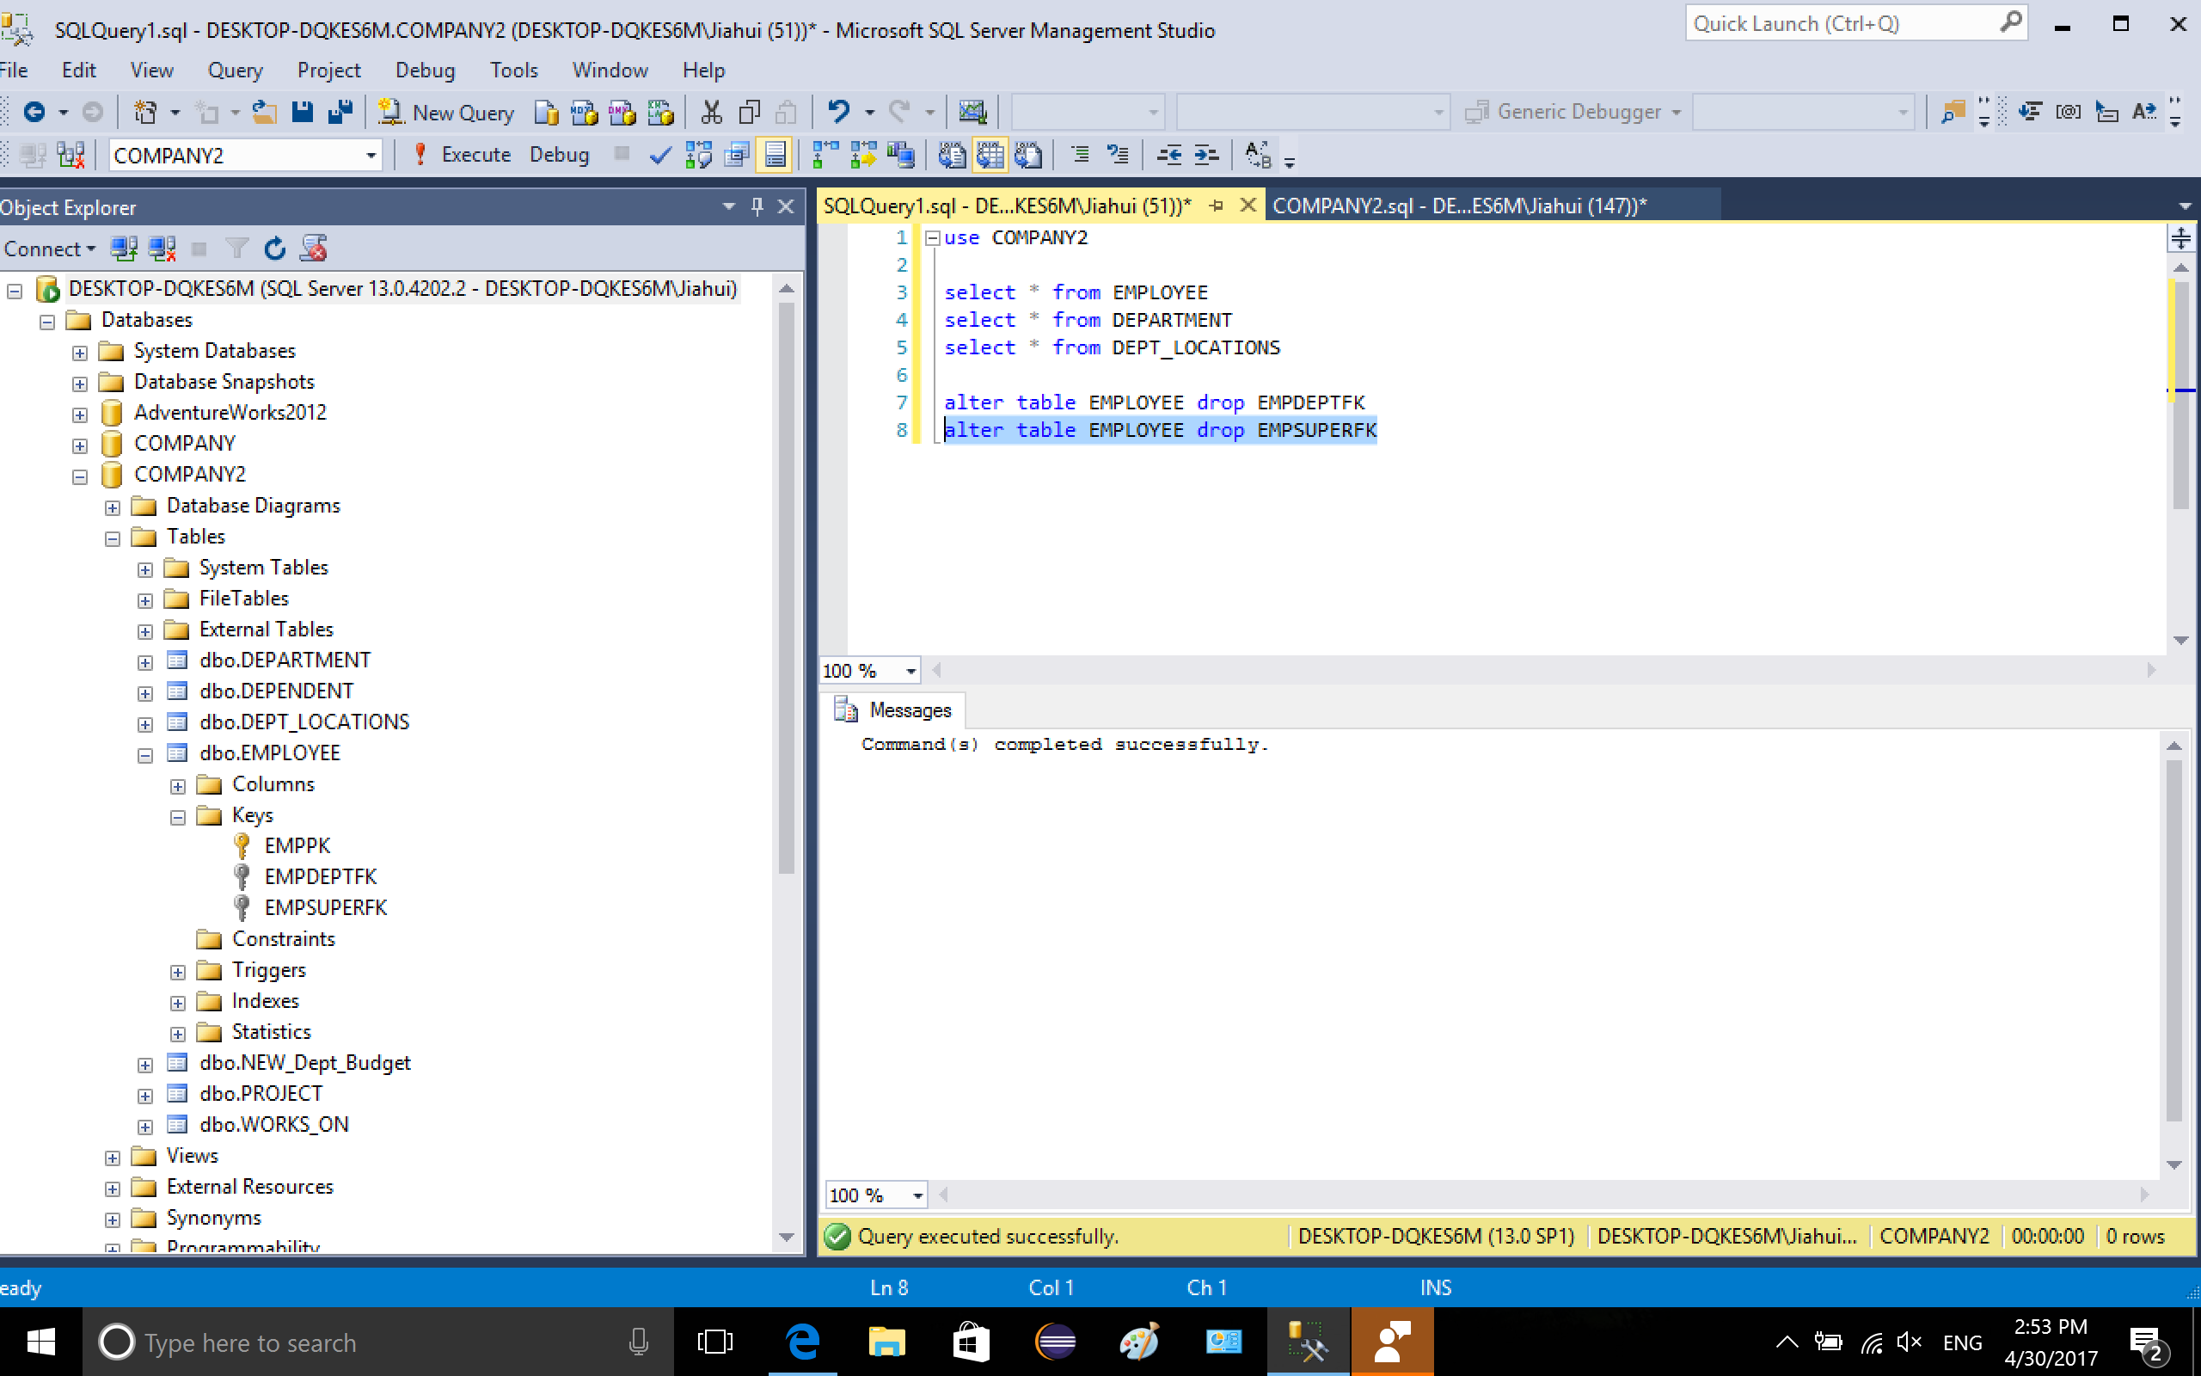

1-3. drop FK of DEPARTMENT that references PK of EMPLOYEE

/Users/jiahuiwu/Desktop/lab6_2/3-1.png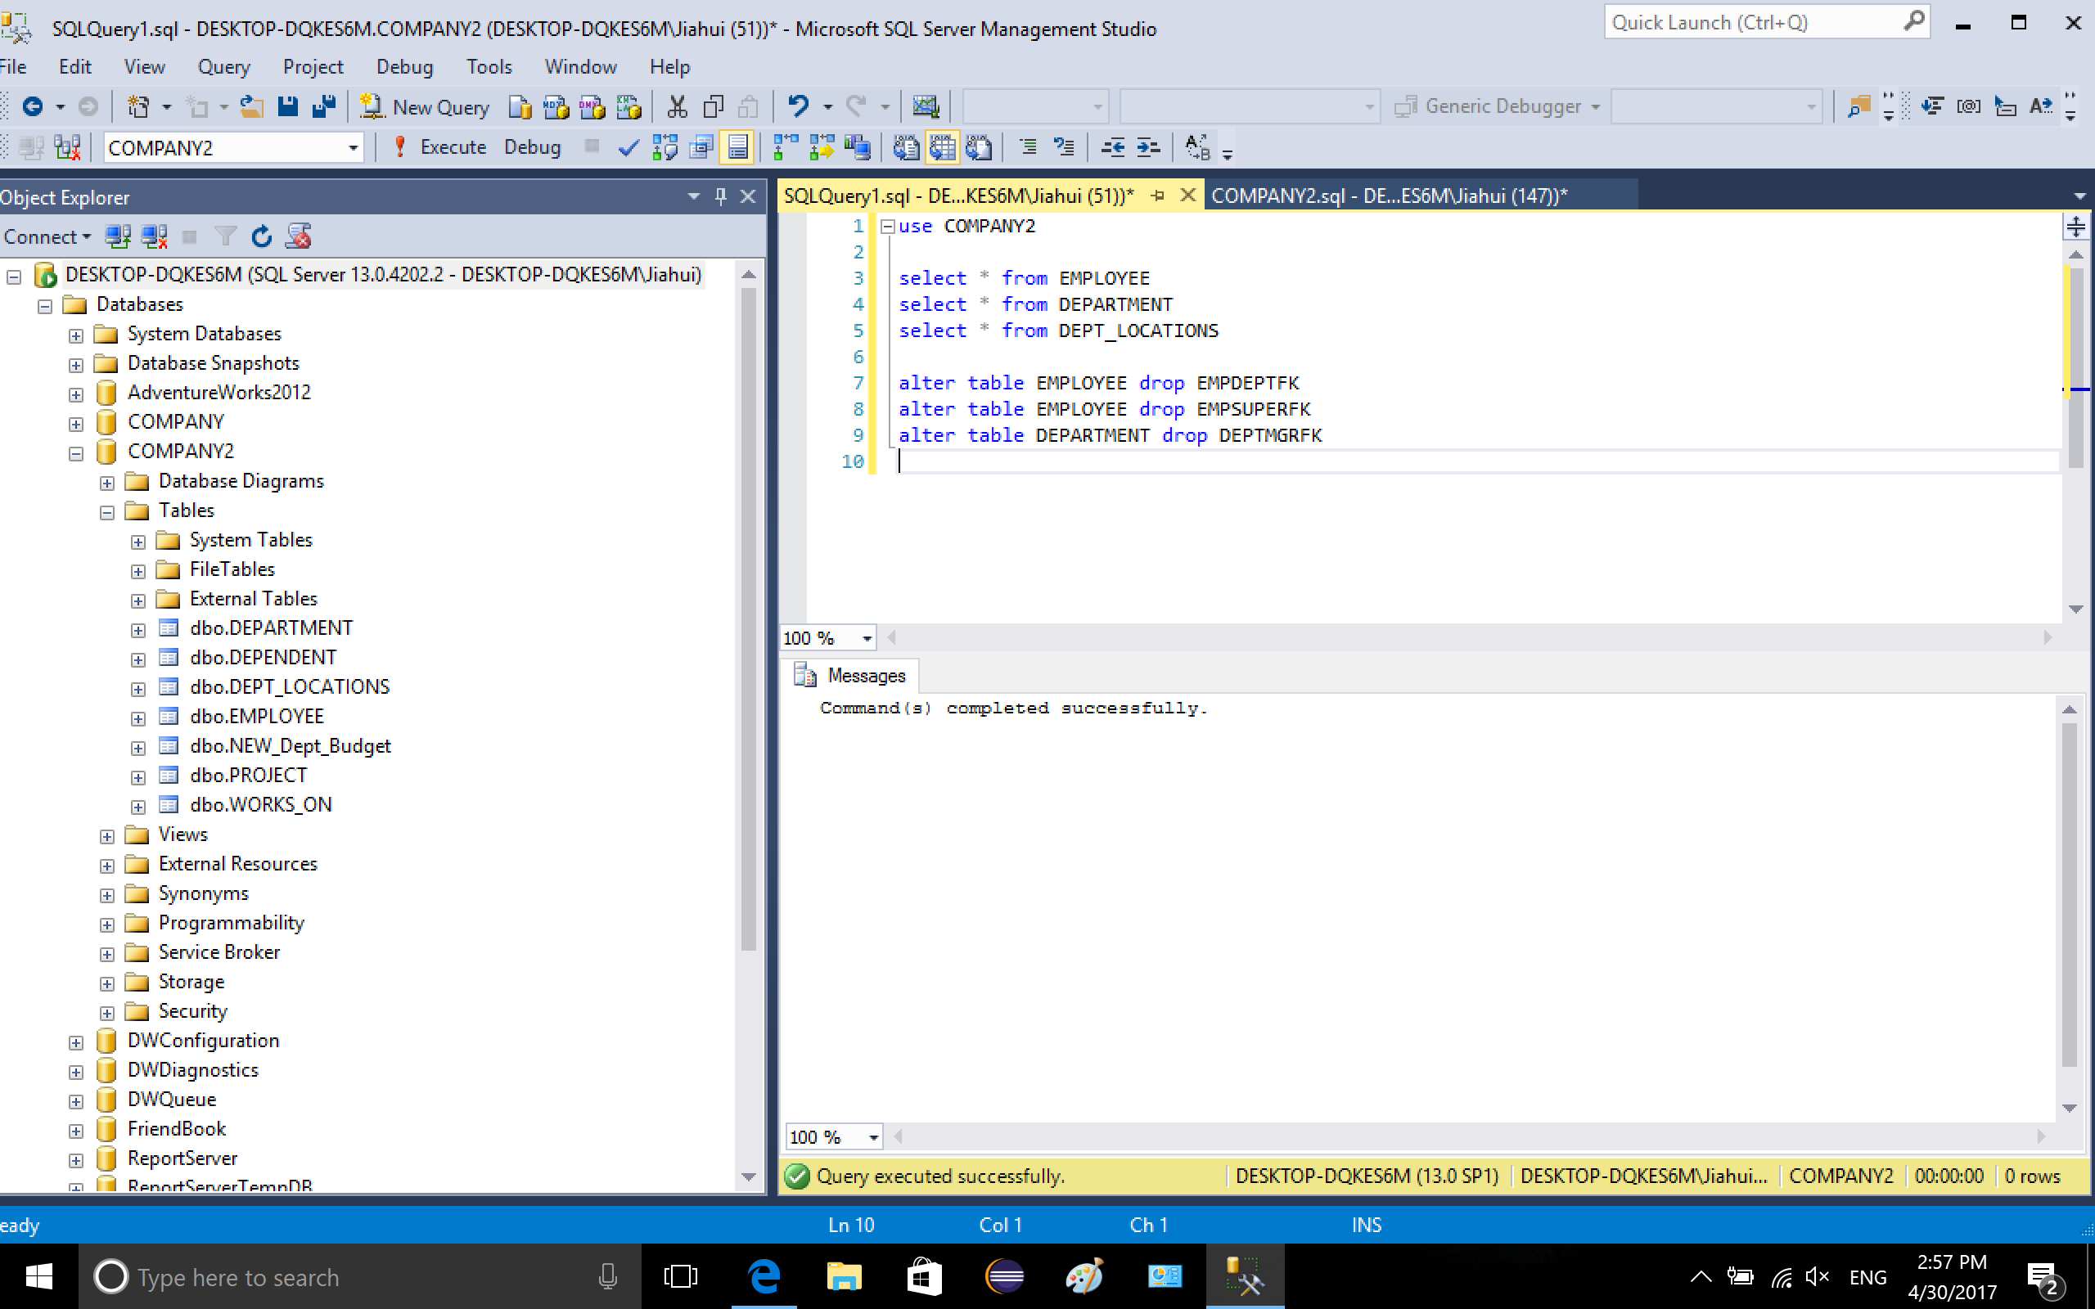

1-4. Drop FK of dependent that references PK of EMPLOYEE

/Users/jiahuiwu/Desktop/lab6_2/4-1.png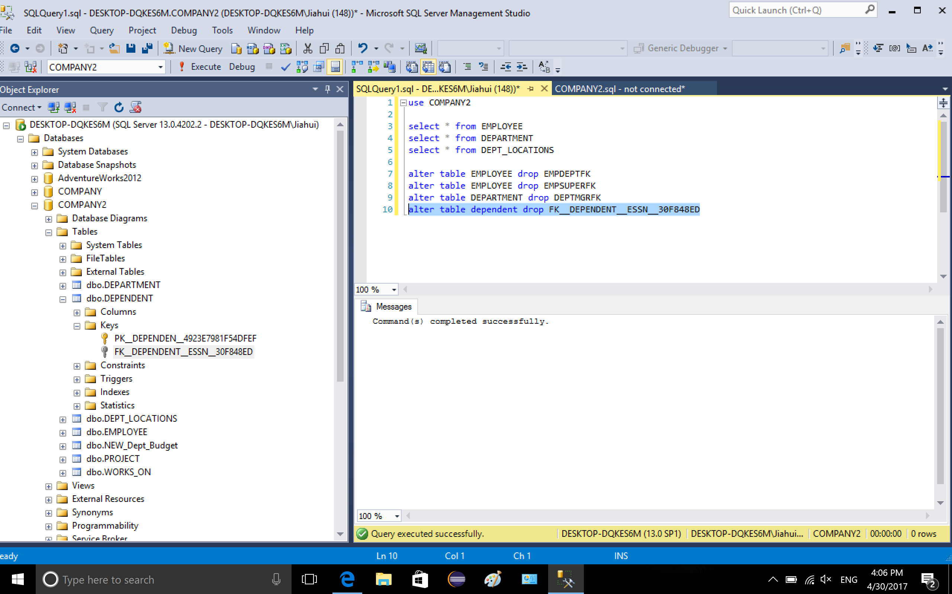

1-5. Drop FK of dept\_locations that references PK of DEPARTMENT/Users/jiahuiwu/Desktop/lab6_2/5-1.png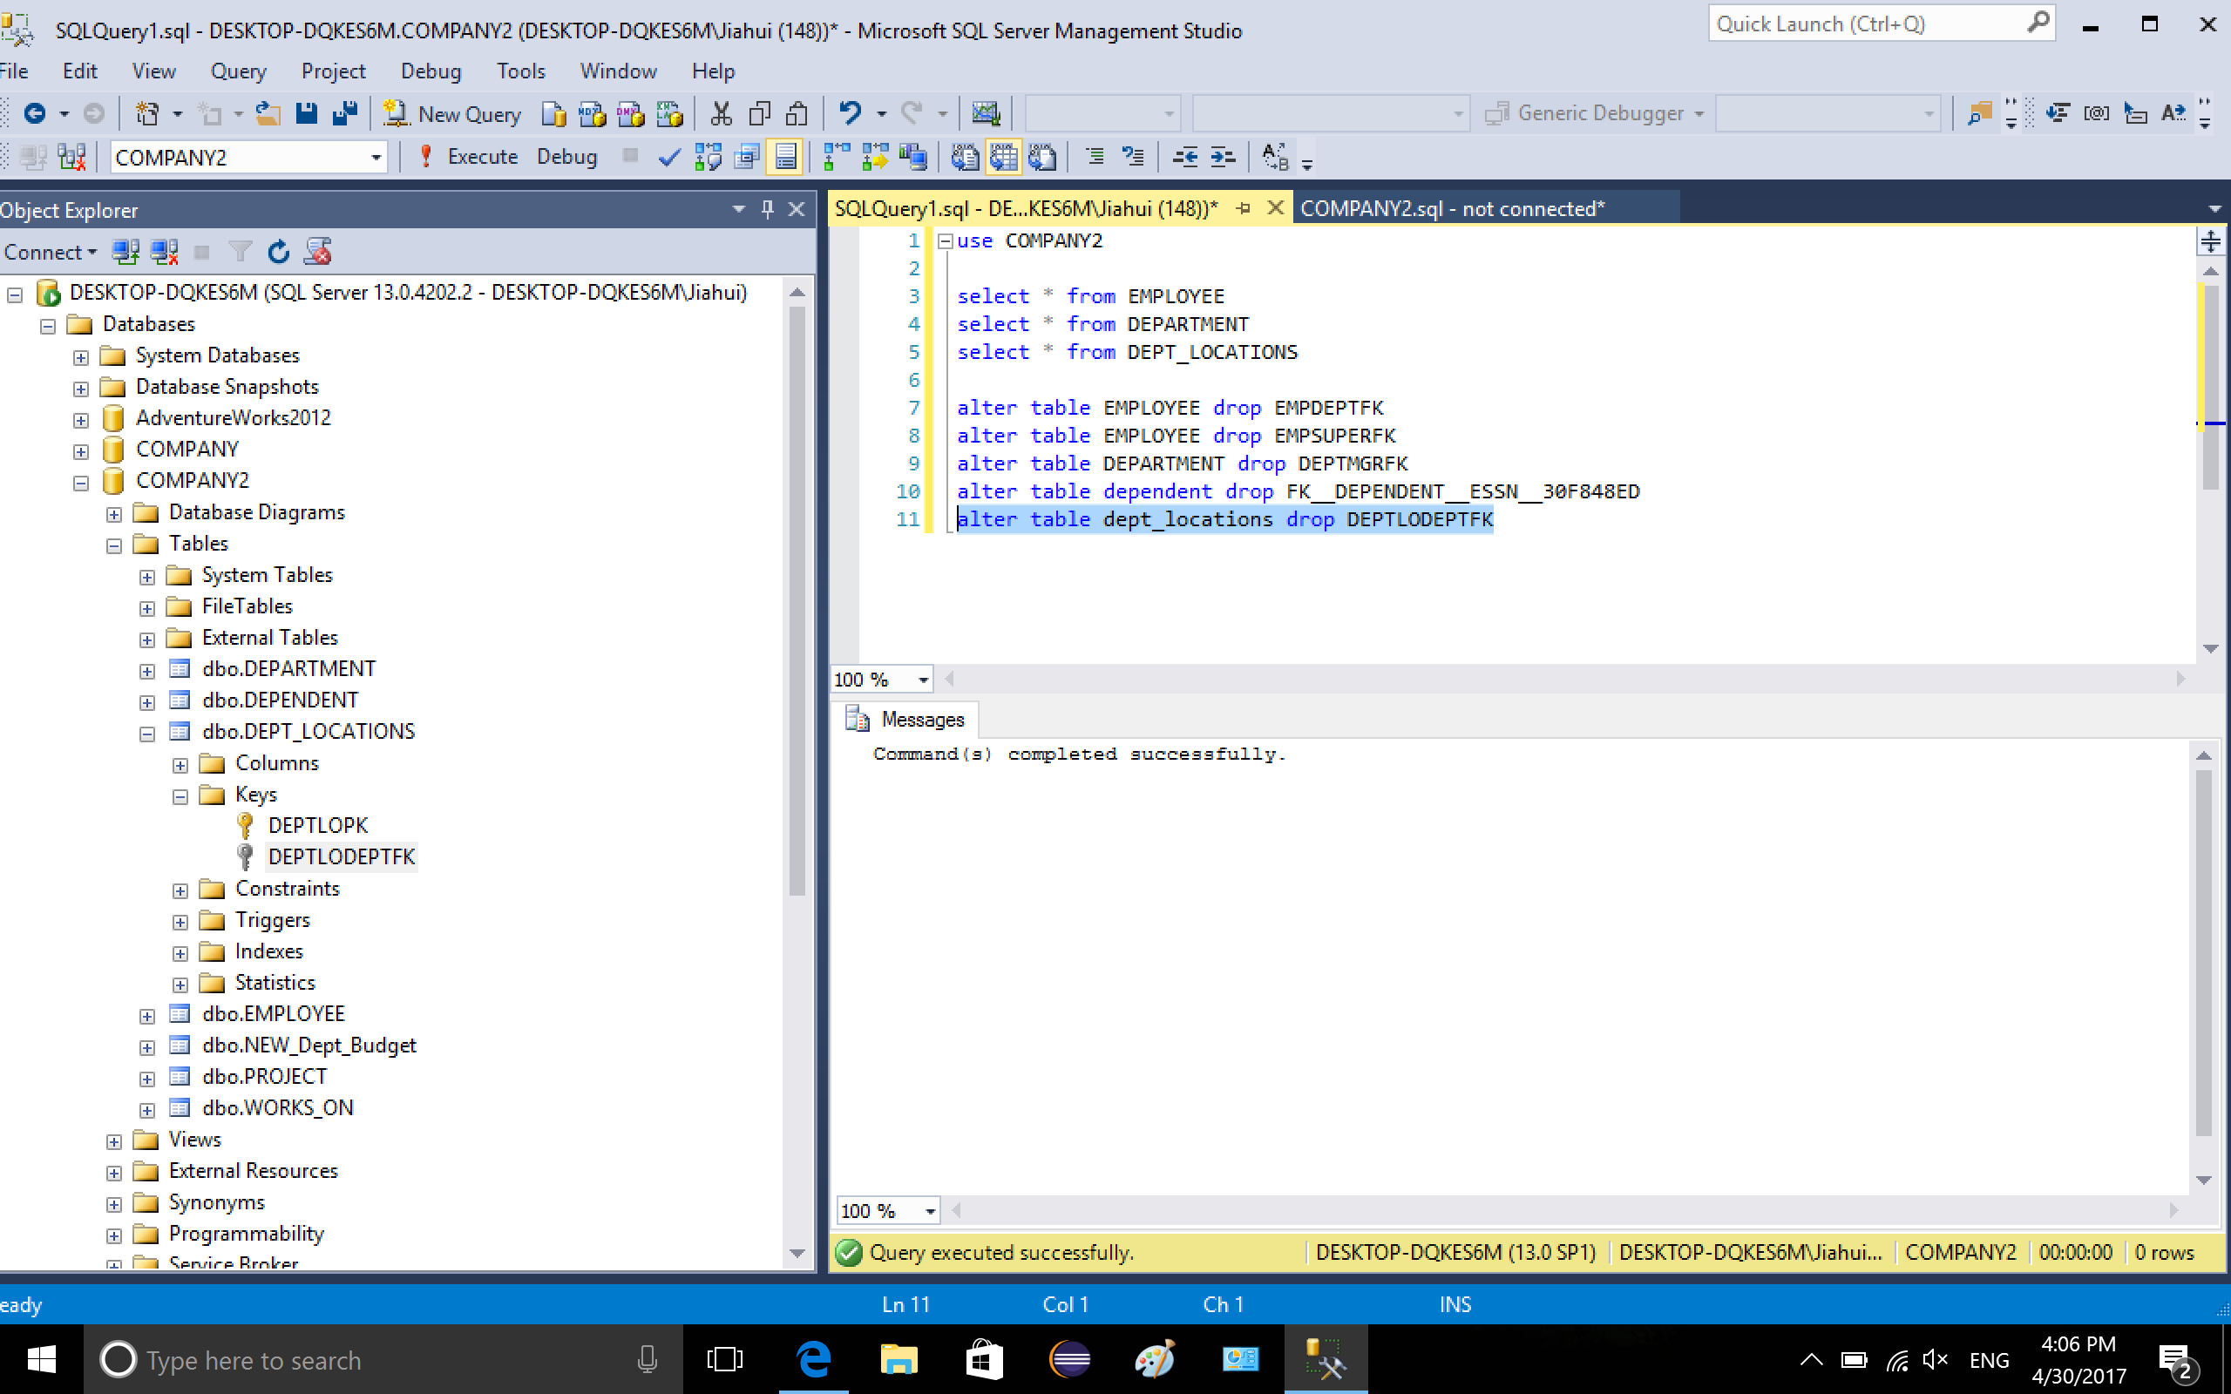

1-6. Drop FK of project that references PK of Department/Users/jiahuiwu/Desktop/lab6_2/6-1.png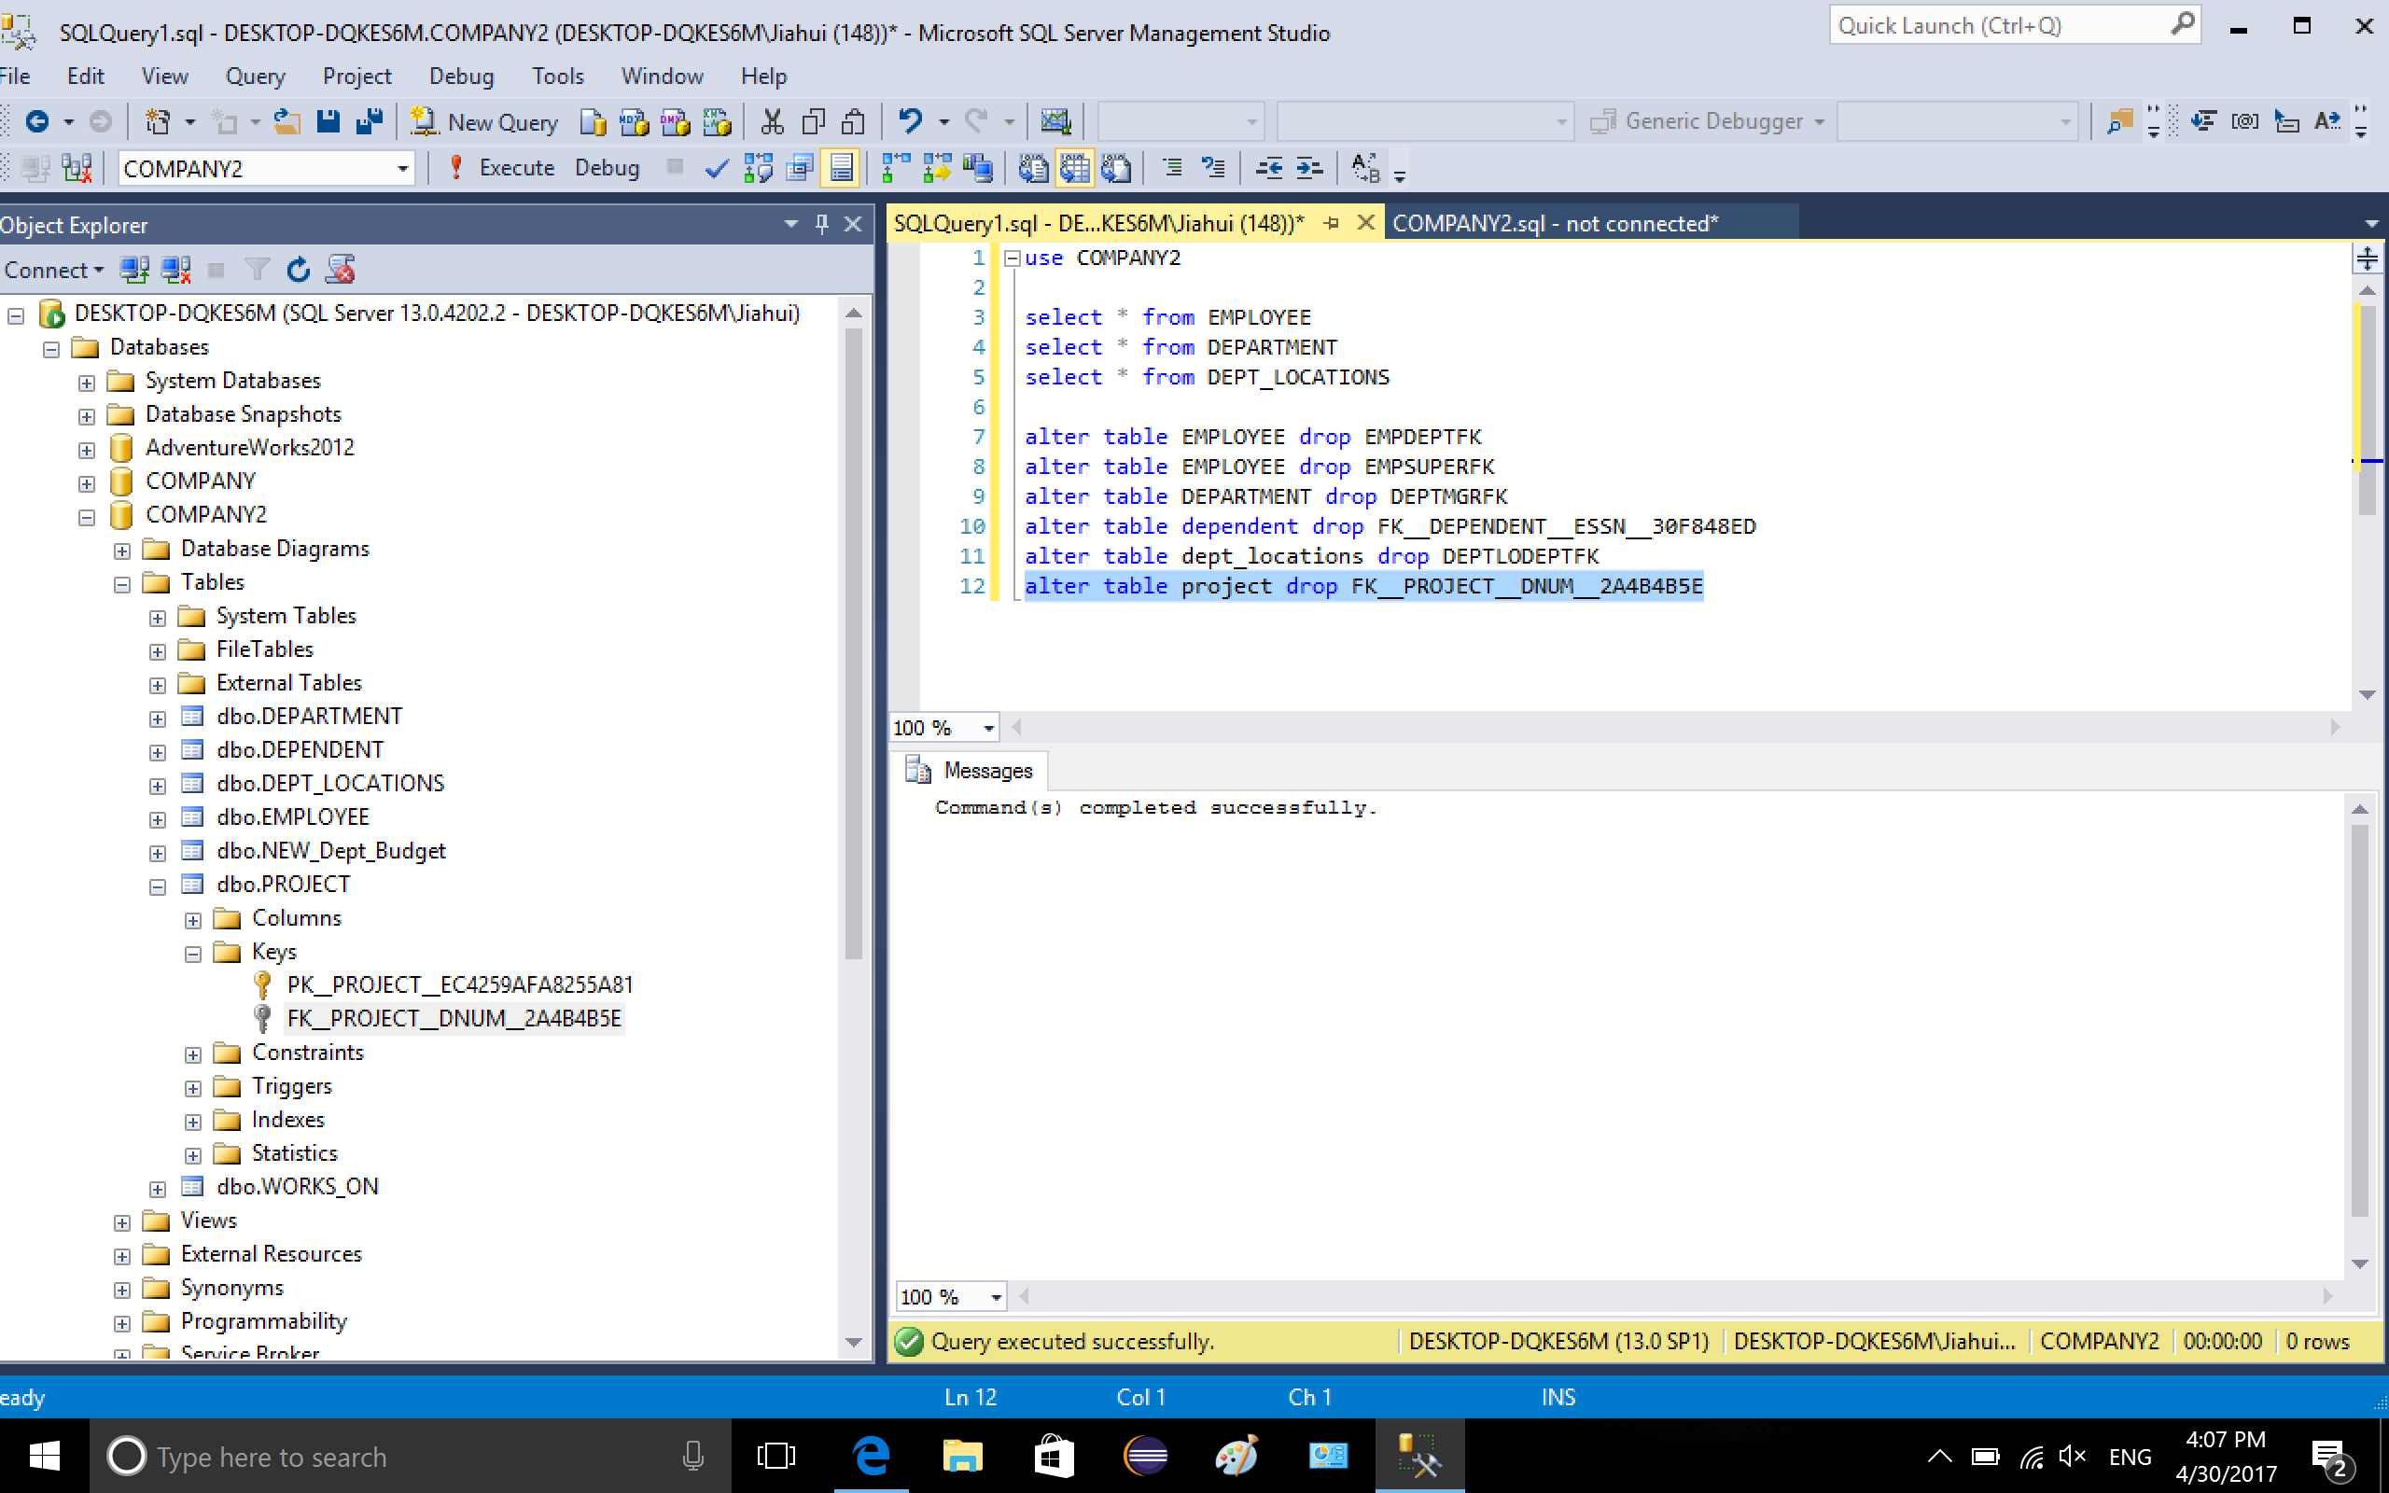

1-7. Drop FK of works\_on that references PK of EMPLOYEE/Users/jiahuiwu/Desktop/lab6_2/7-1.png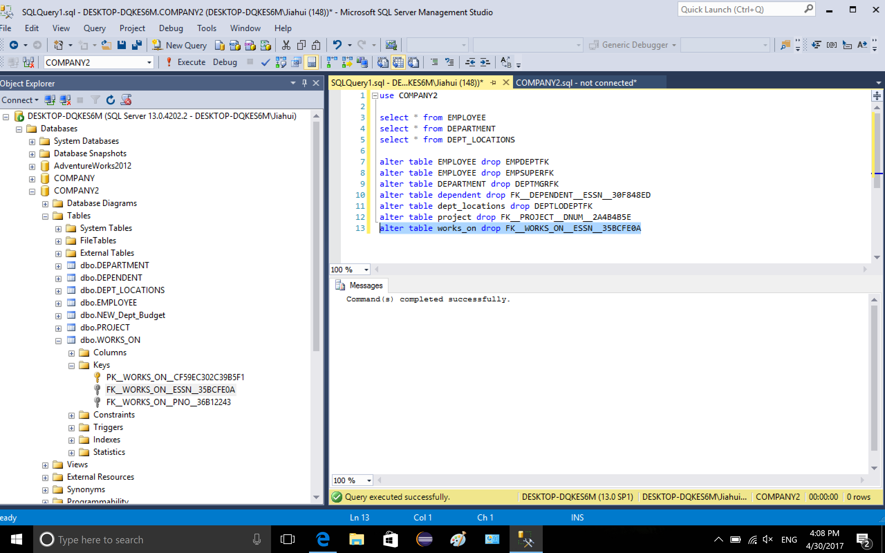

1-8. Drop PK of EMPLOYEE

/Users/jiahuiwu/Desktop/lab6_2/8-1.png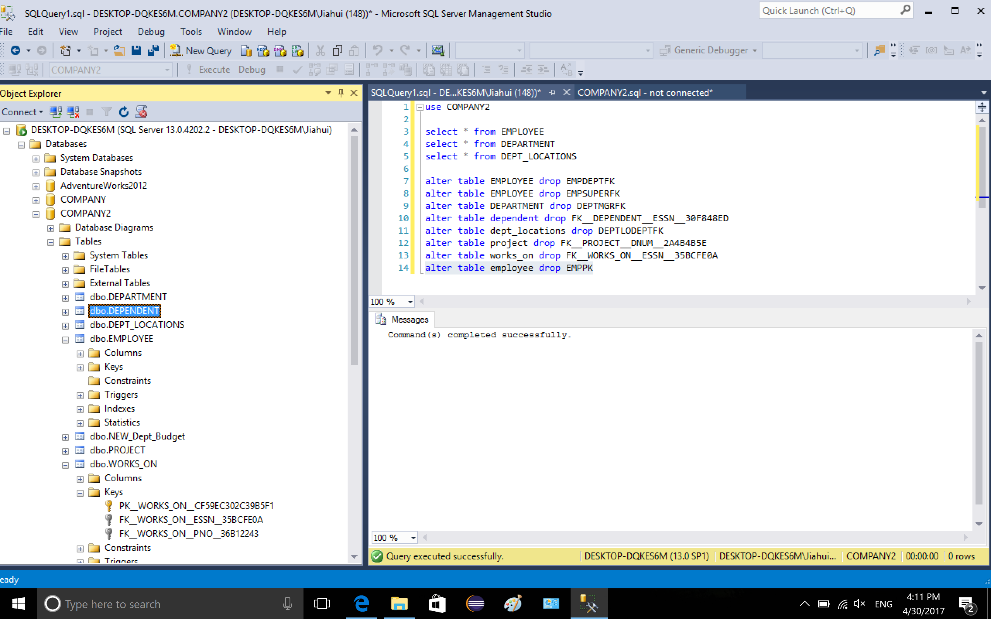

1-9. Drop PK of DEPARTMENT

/Users/jiahuiwu/Desktop/lab6_2/9-1.png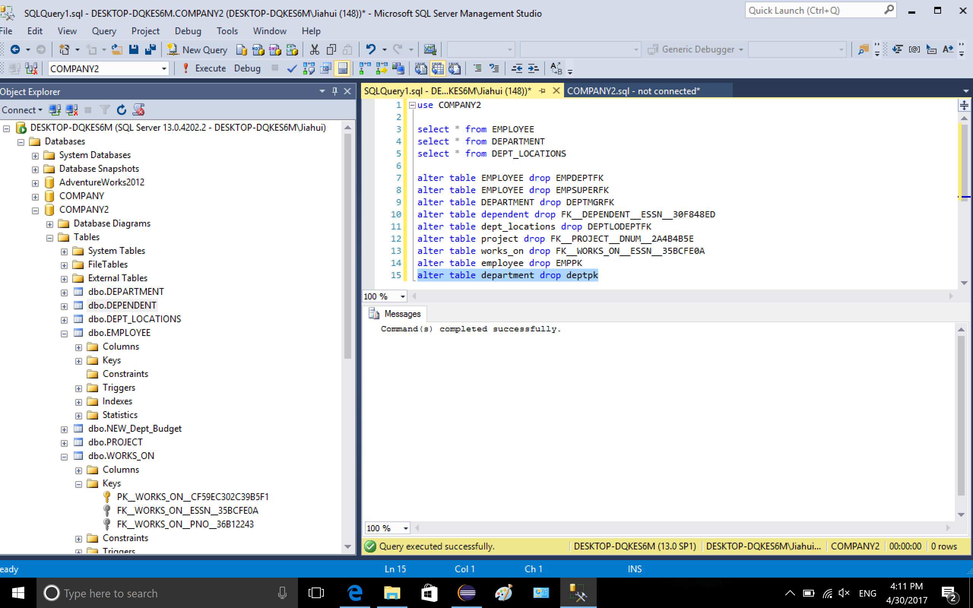

2. create stored procedure, the procedure takes 7 arguments, the function of the procedure is first to check if the table SP\_Audit\_Dept was built, if not, create table, otherwise, insert the arguments into table Audit\_Dept\_Table.

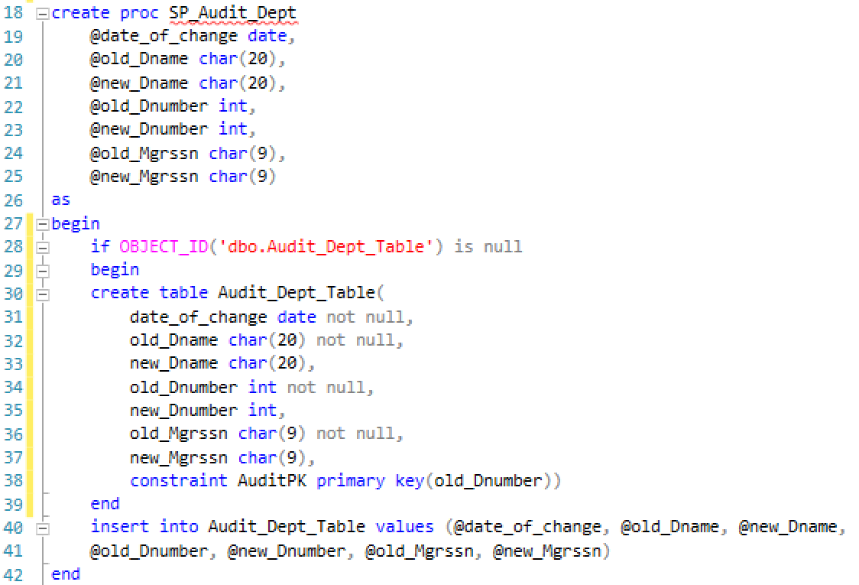

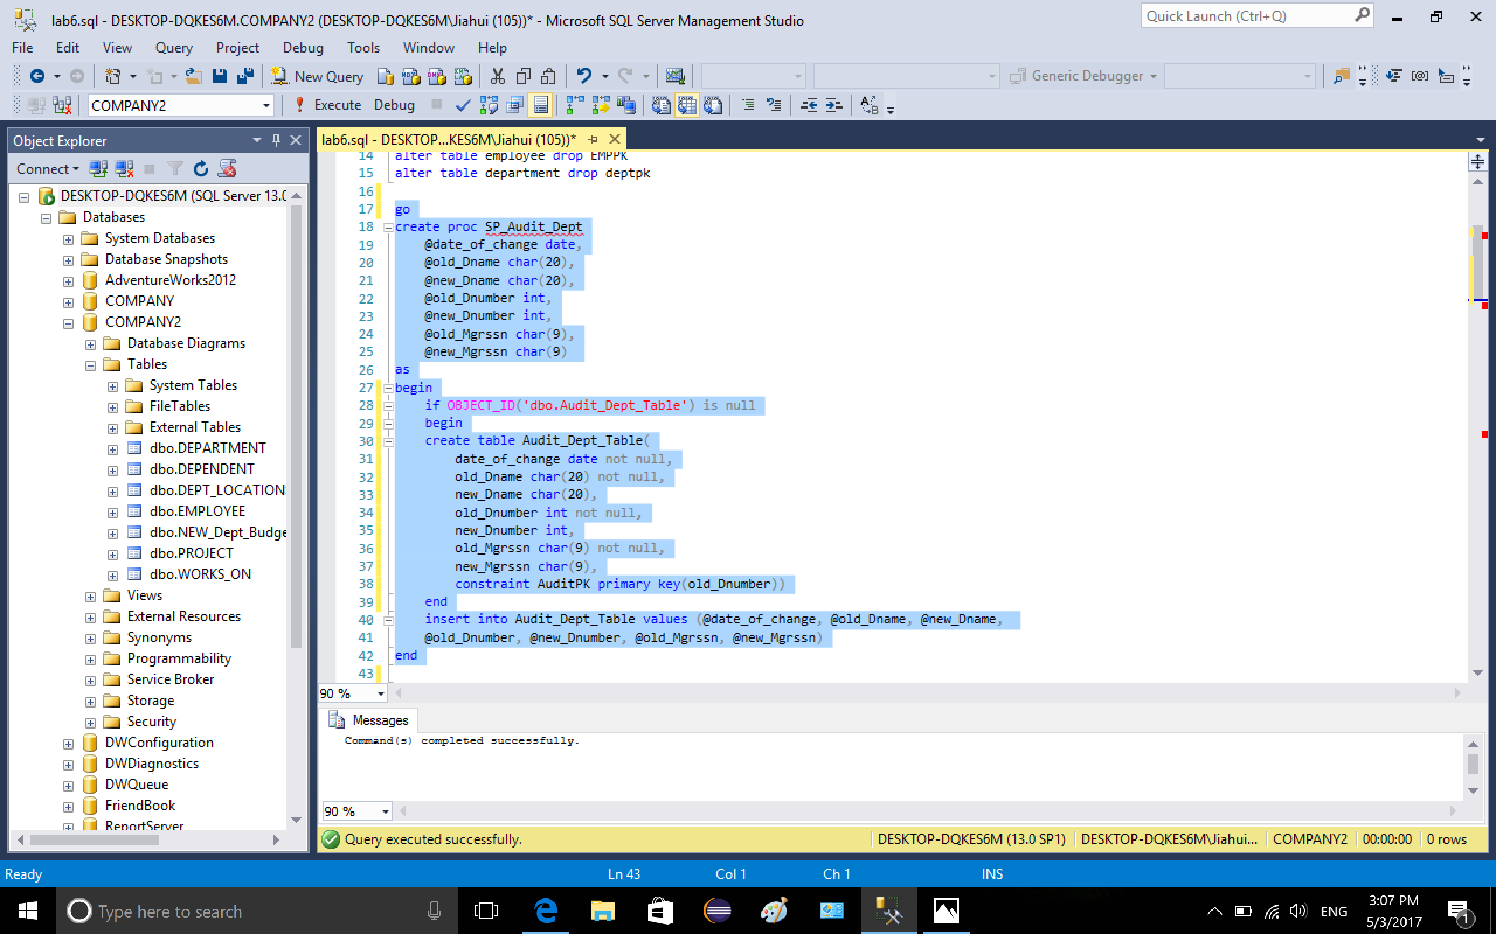

3-1. create trigger EMPDEPT1 on department for update

first, there is an if condition to check is DNUMBER is updated, in the condition, the attributes in audit table are declared and set, the DNO in table EMPLOYEE is set to new\_Dnumber. Then it comes to another if condition to compare the old\_Dnumber and new\_Dnumber. If they are not the same, the procedure will be executed and audit table will be inserted.

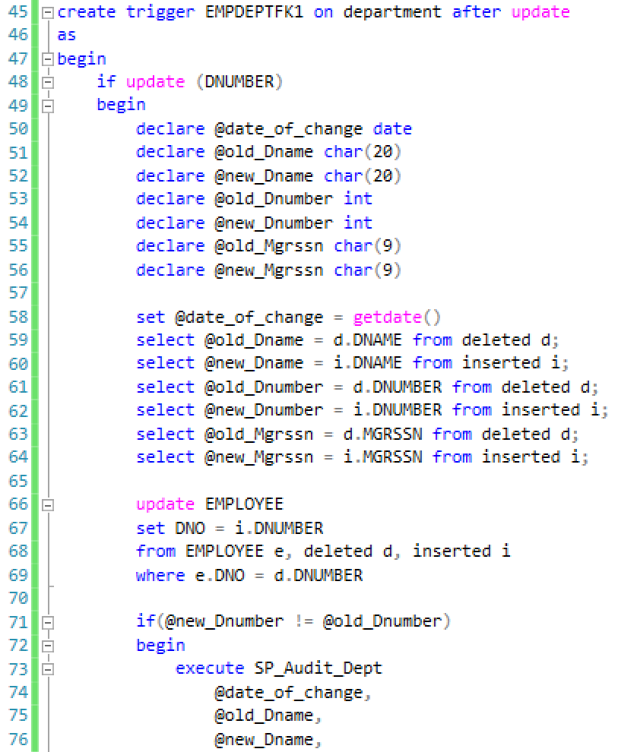

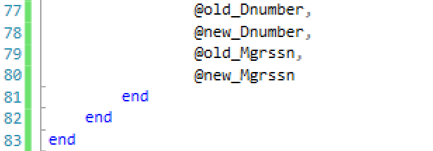

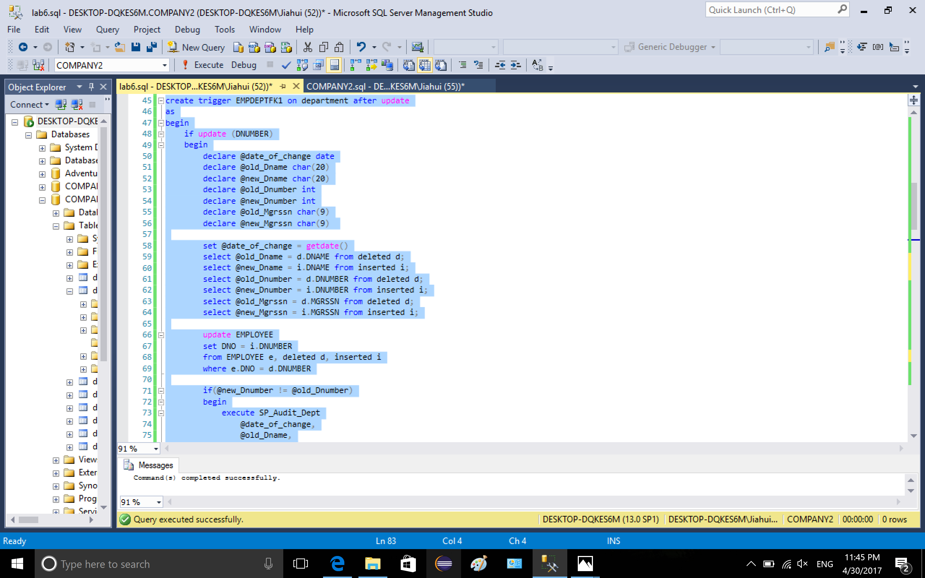

3-2. Before updating

../lab6_2/13-1.png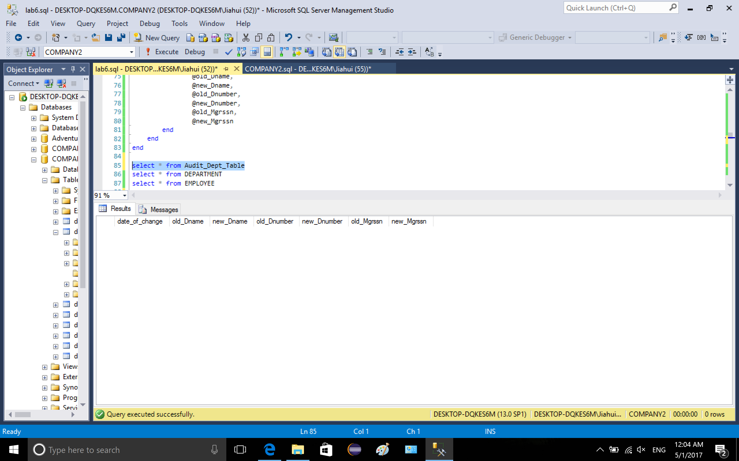../lab6_2/14-1.png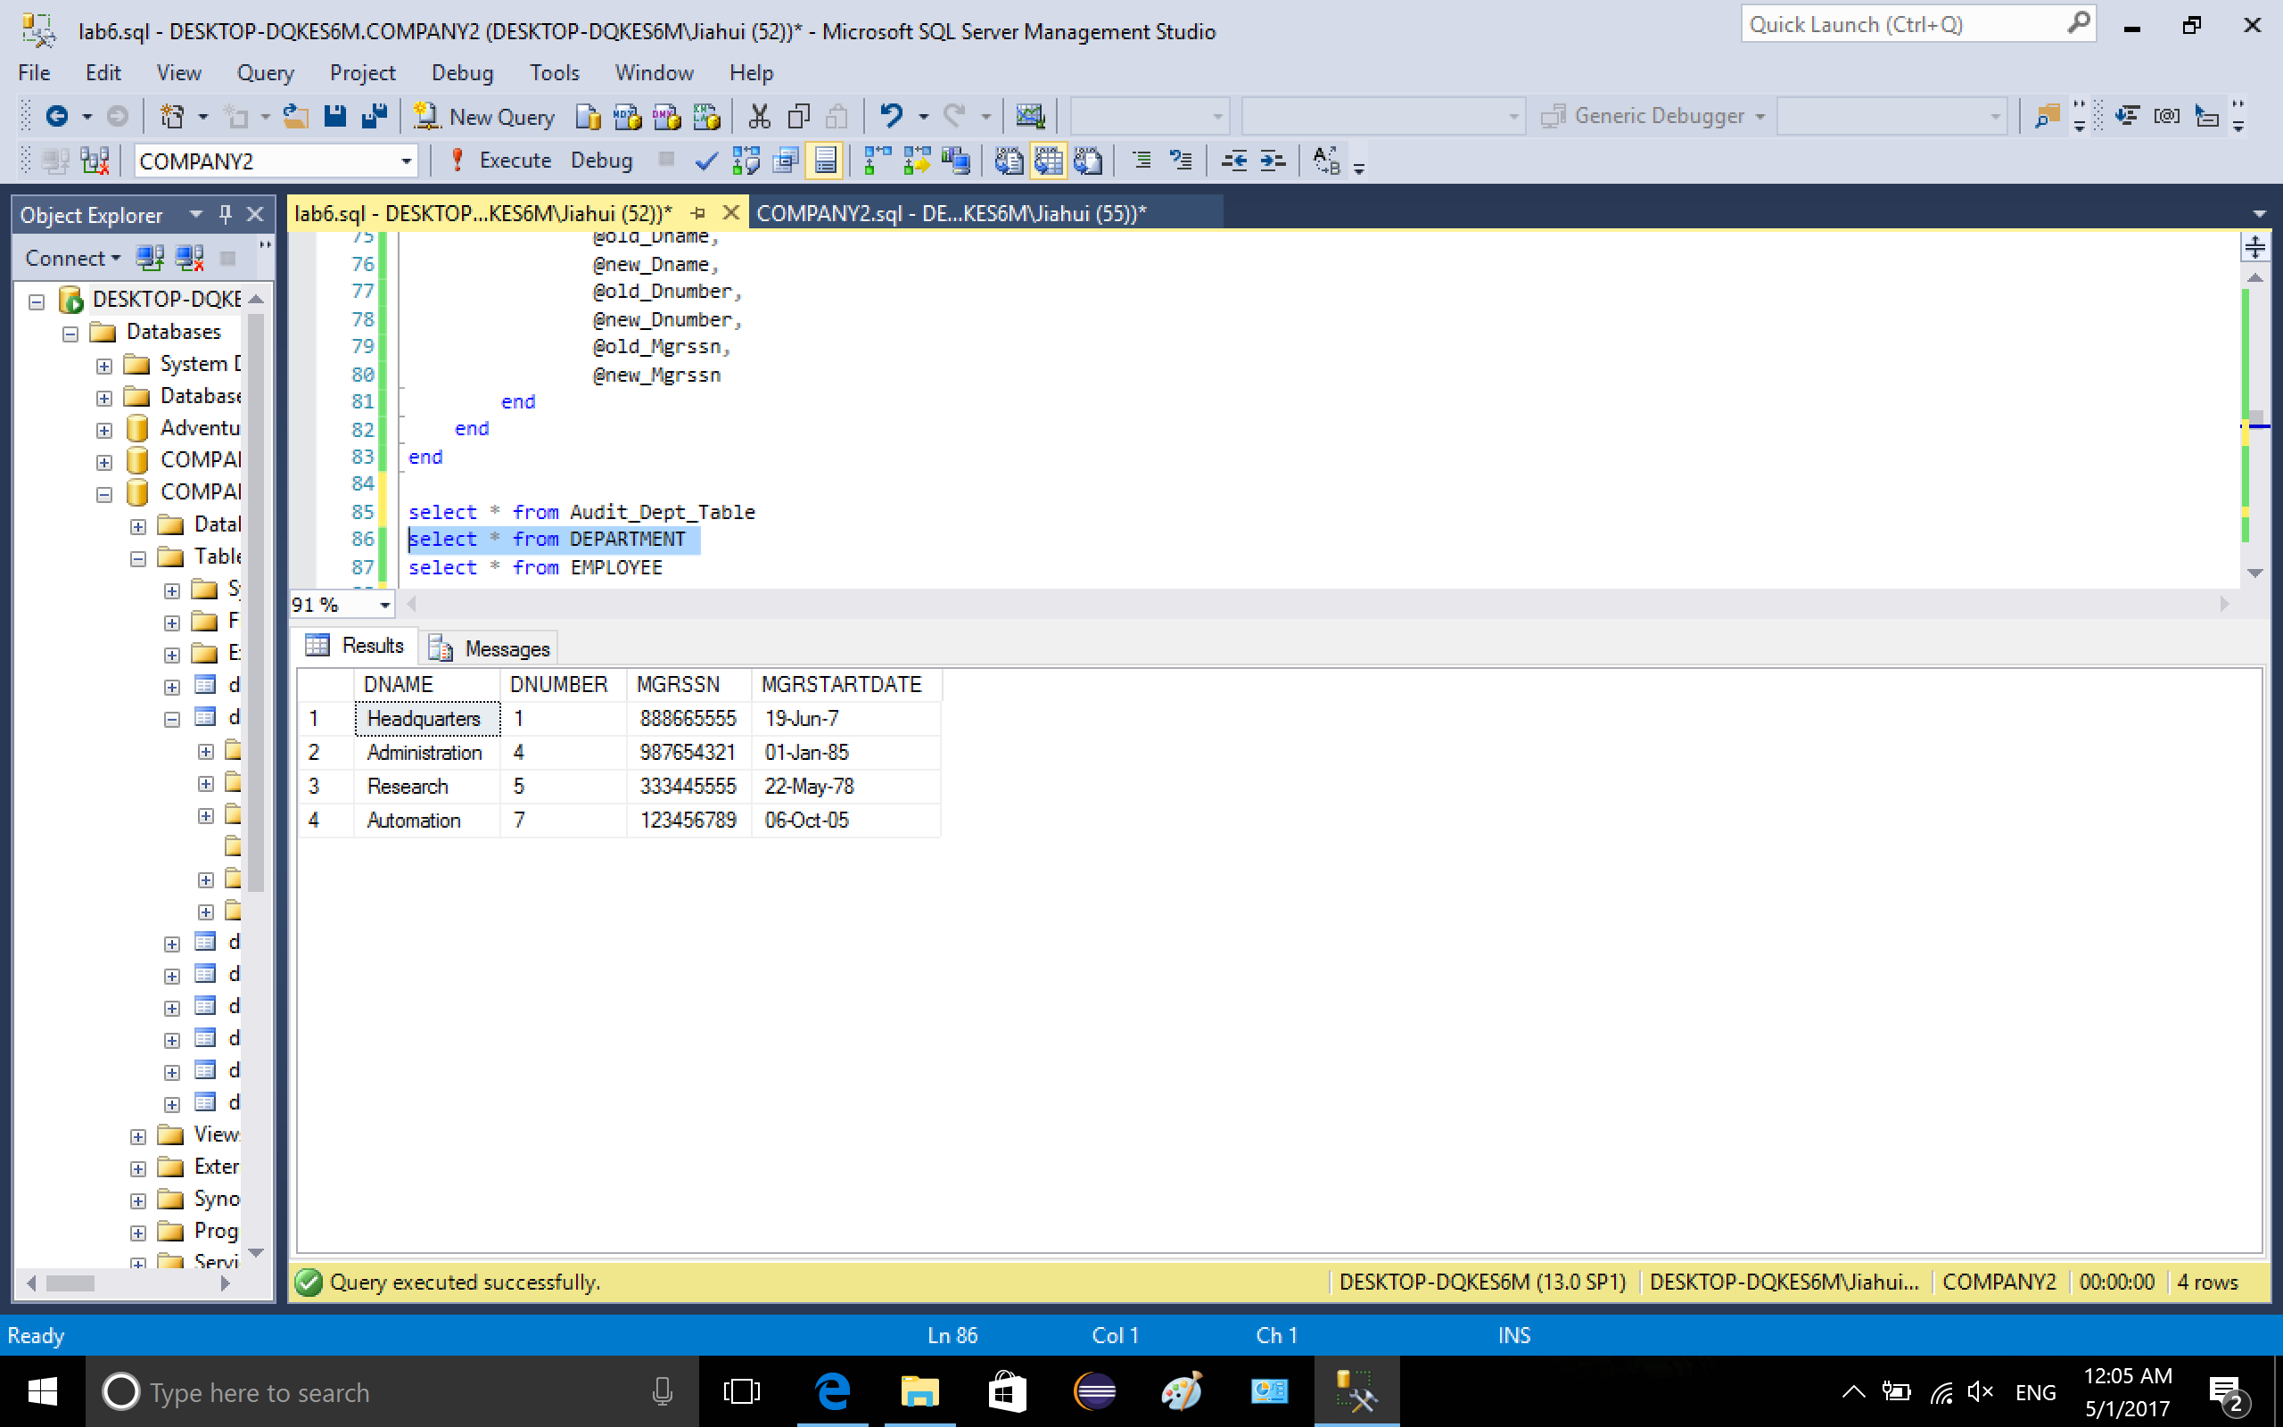../lab6_2/15-1.png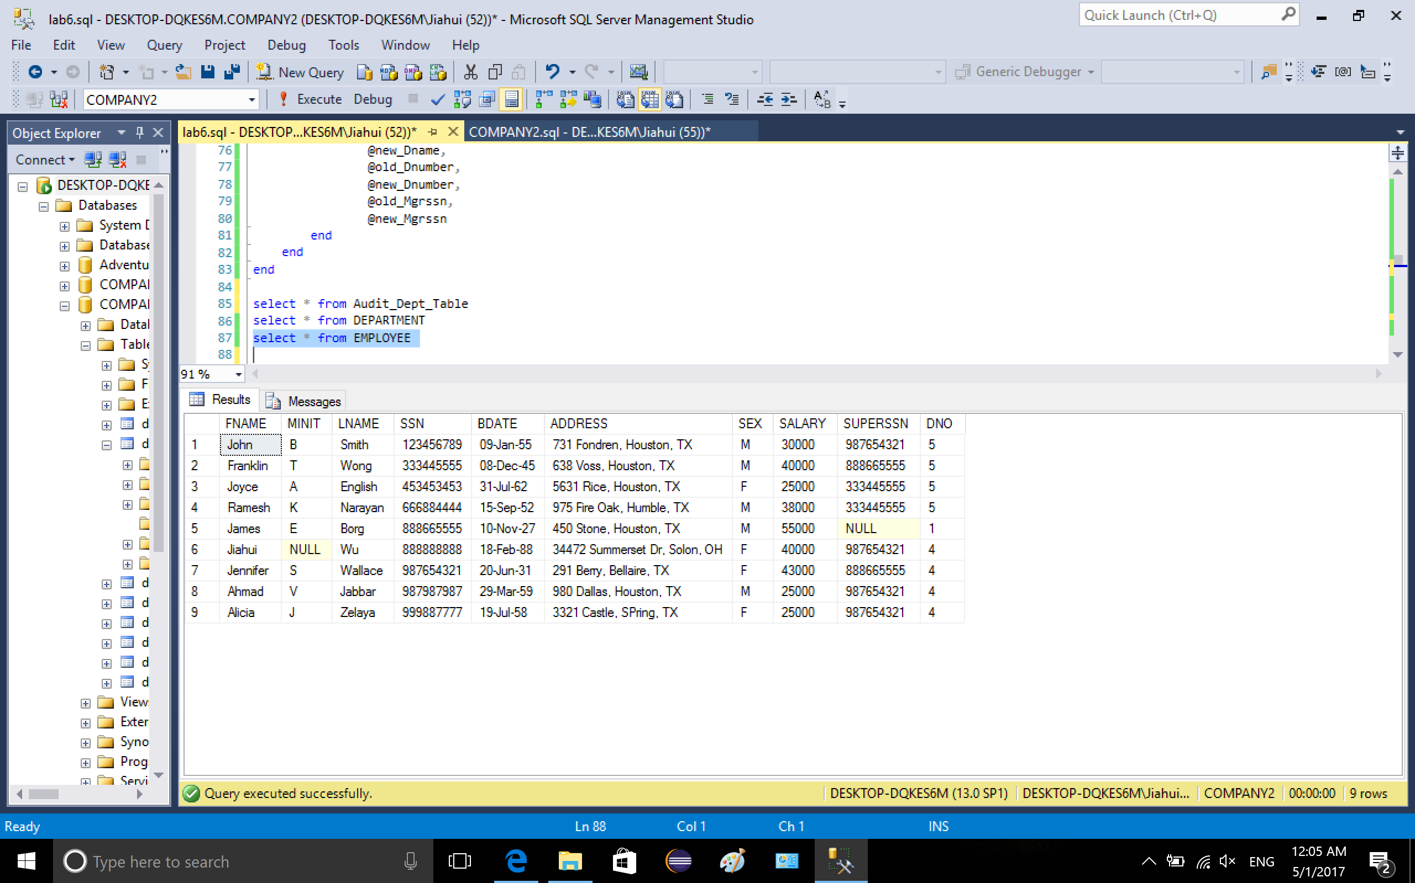

3-3. update department dnumber from 4 to 99

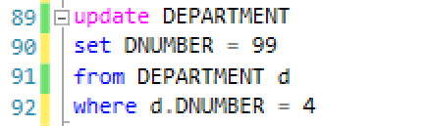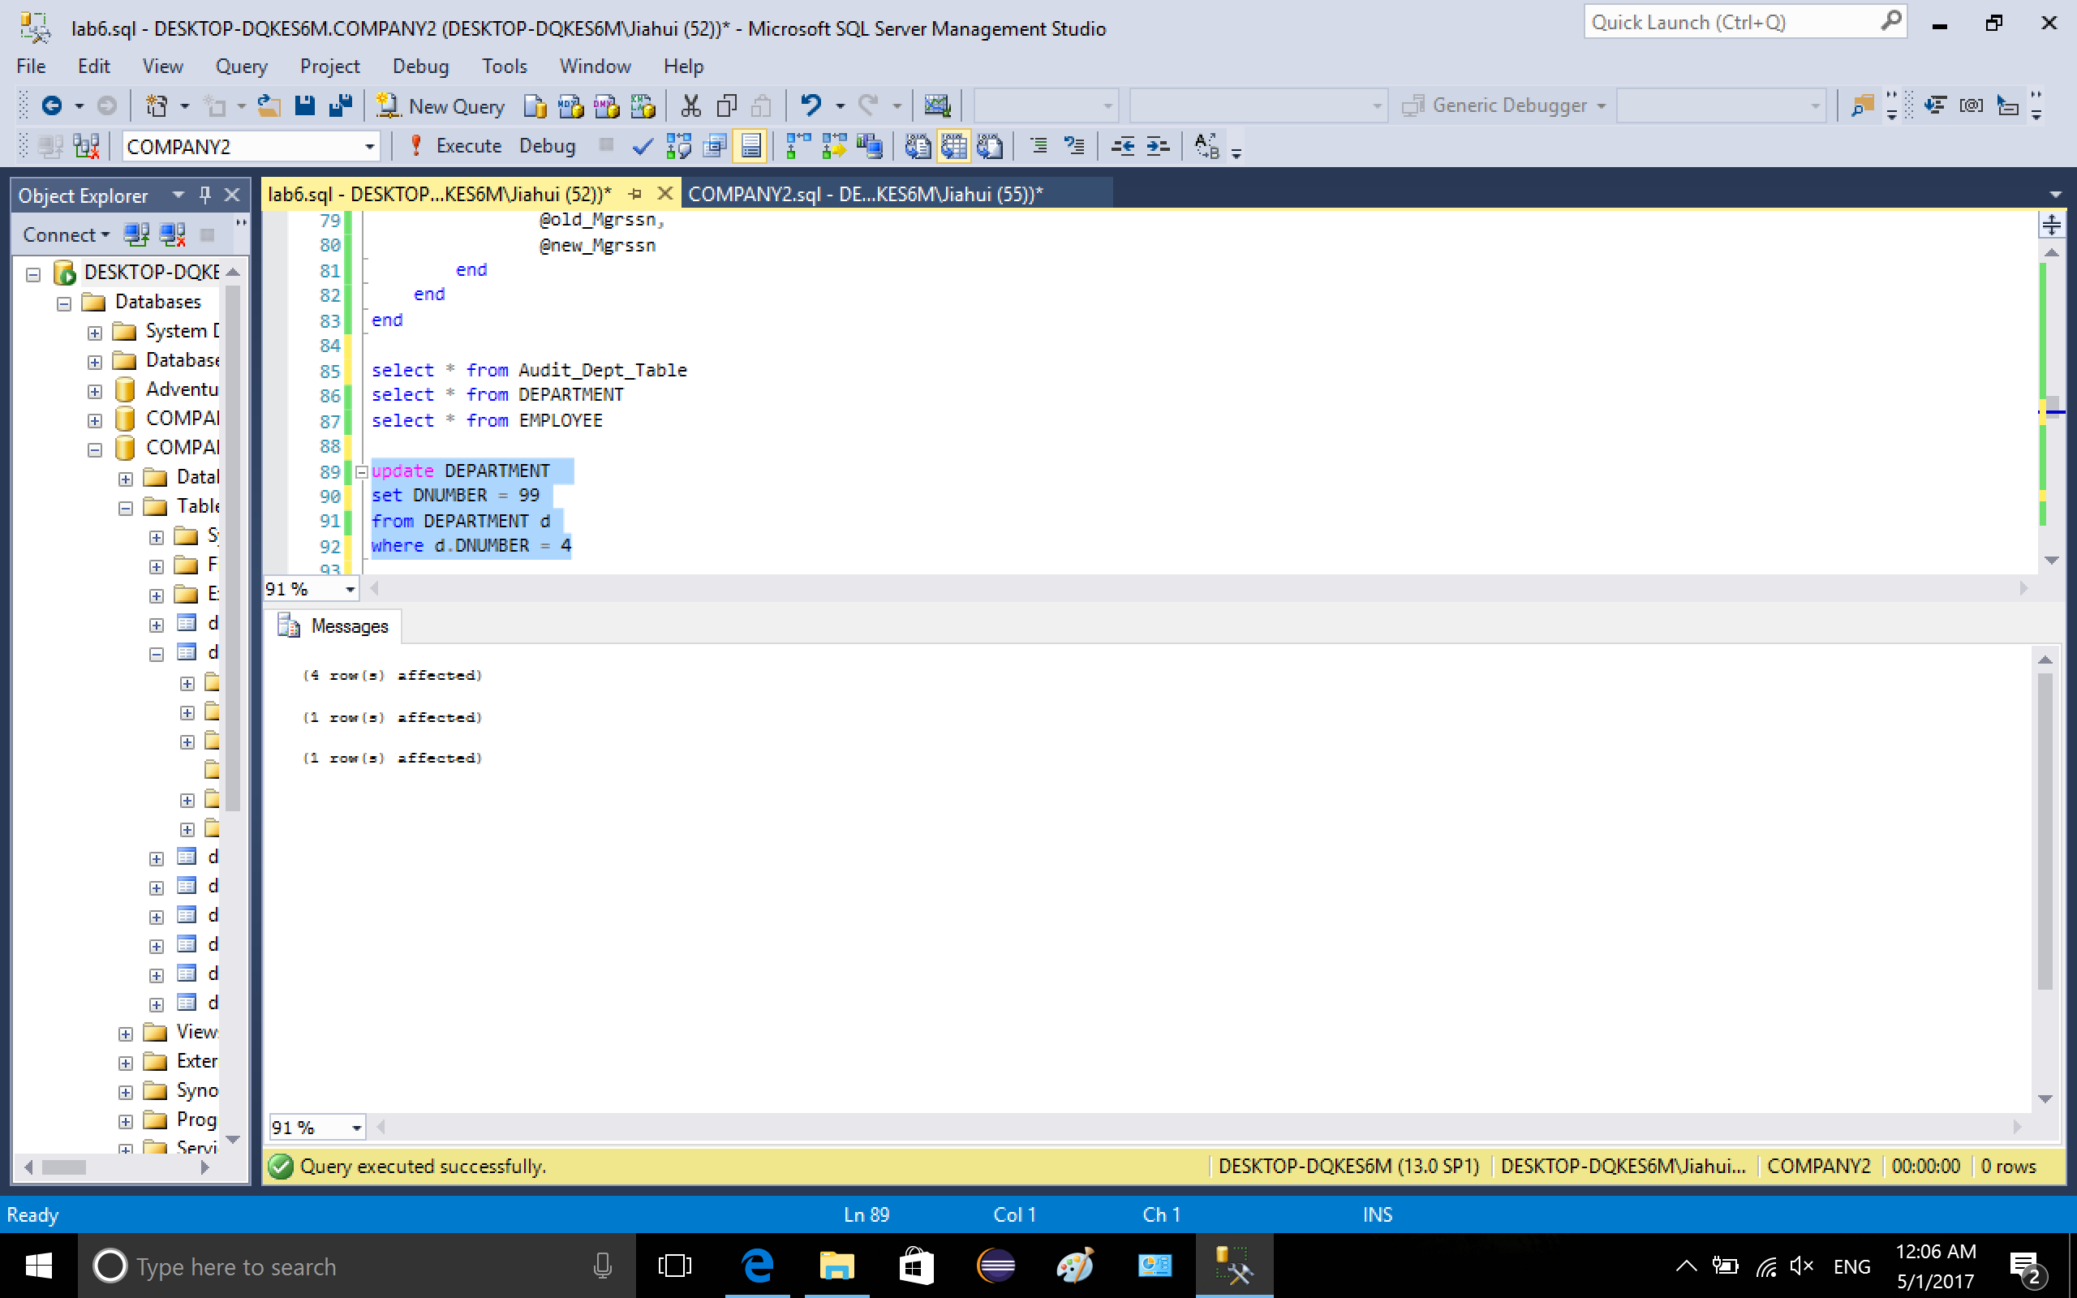

3-4. after updating. Audit\_Dept\_Table (explanation is in the in the following picture)

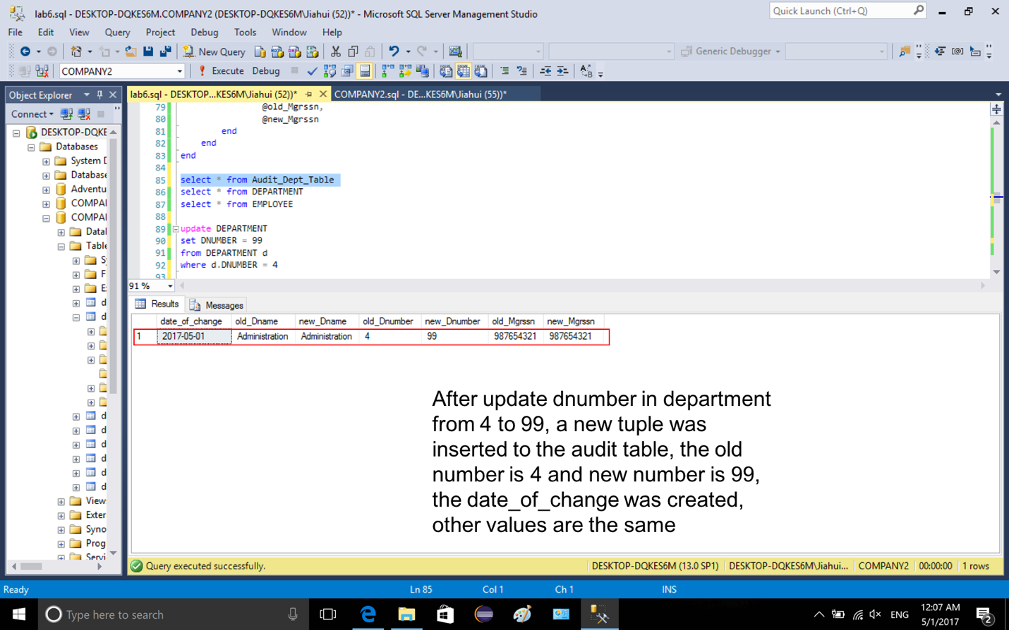

Department table (explanation is in the following picture)

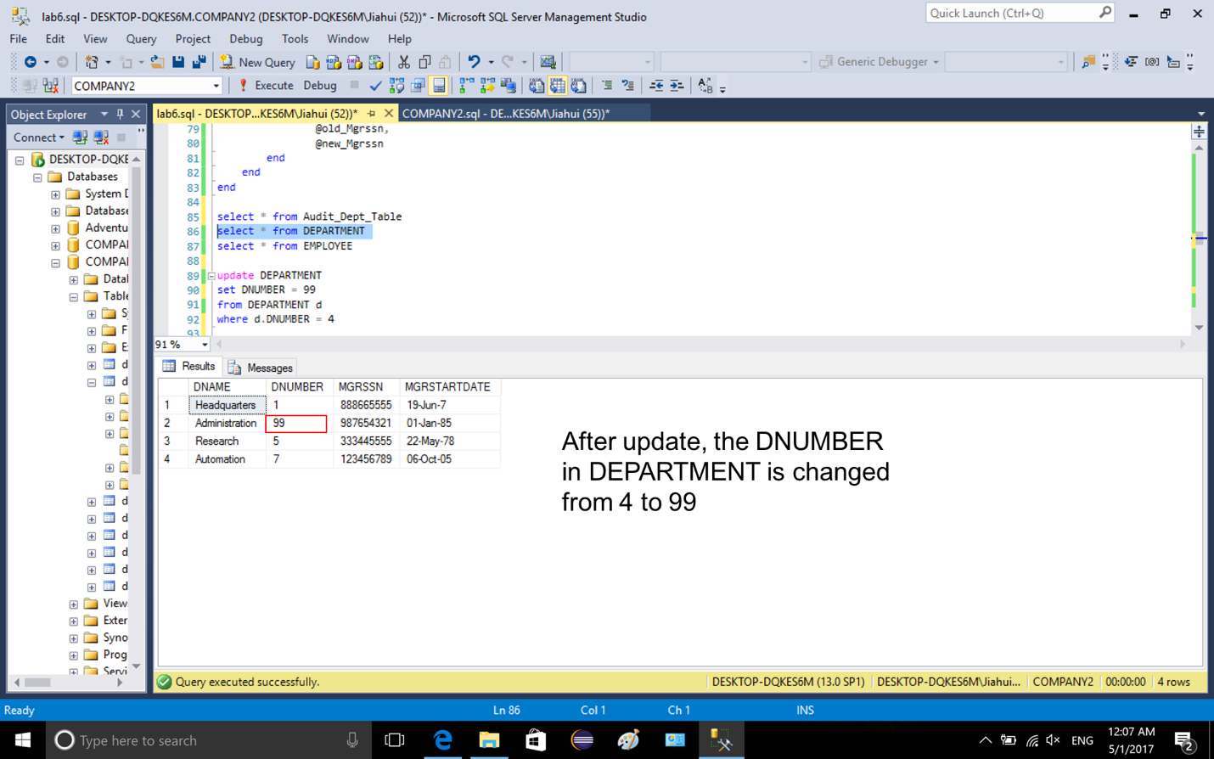

Employee table (explanation is in the following picture)

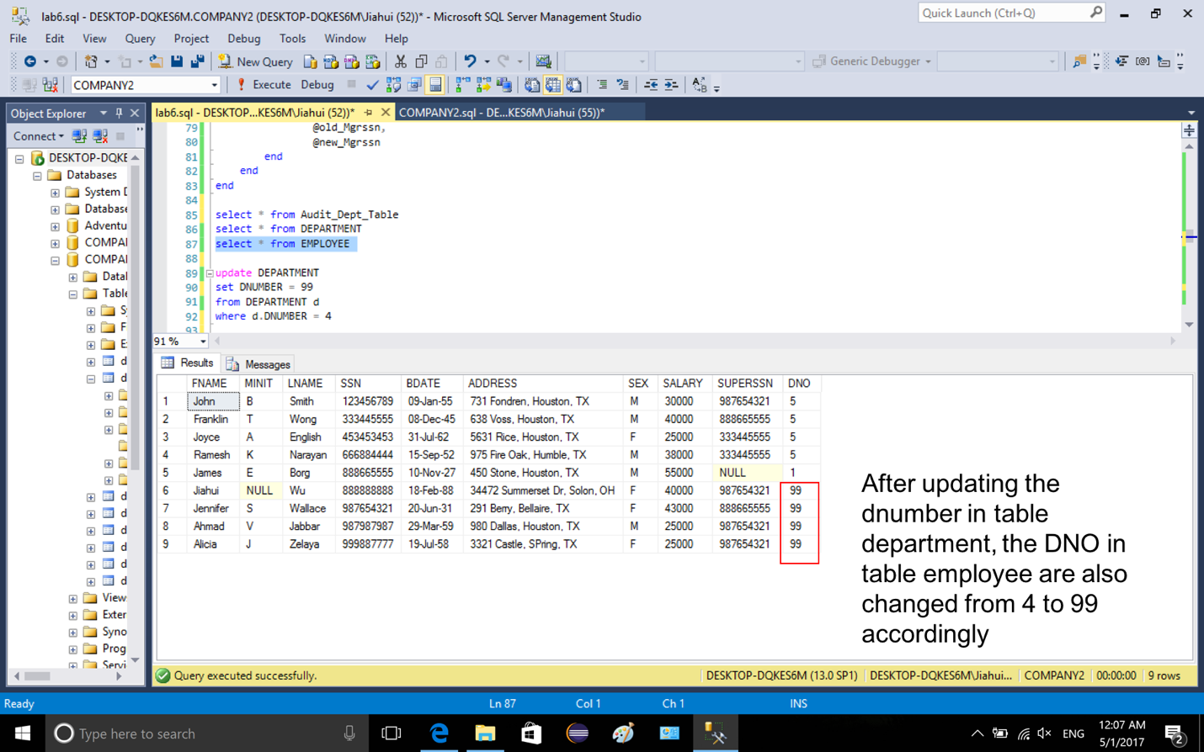

4-1. create trigger EMPDEPTFK2 on department after delete. First, declare the variables in audit table, and set the old values from deleted table, set new values from inserted table (because there is no insertion, the value would be null). If the new value is null, DNO in table EMPLOYEE will be set to 1, the audit table will also be updated.

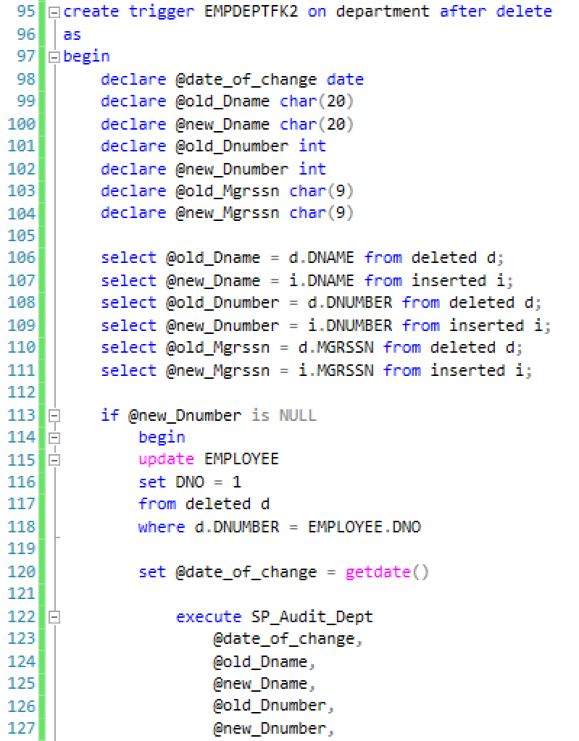

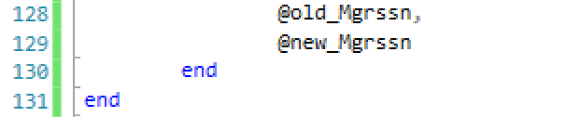

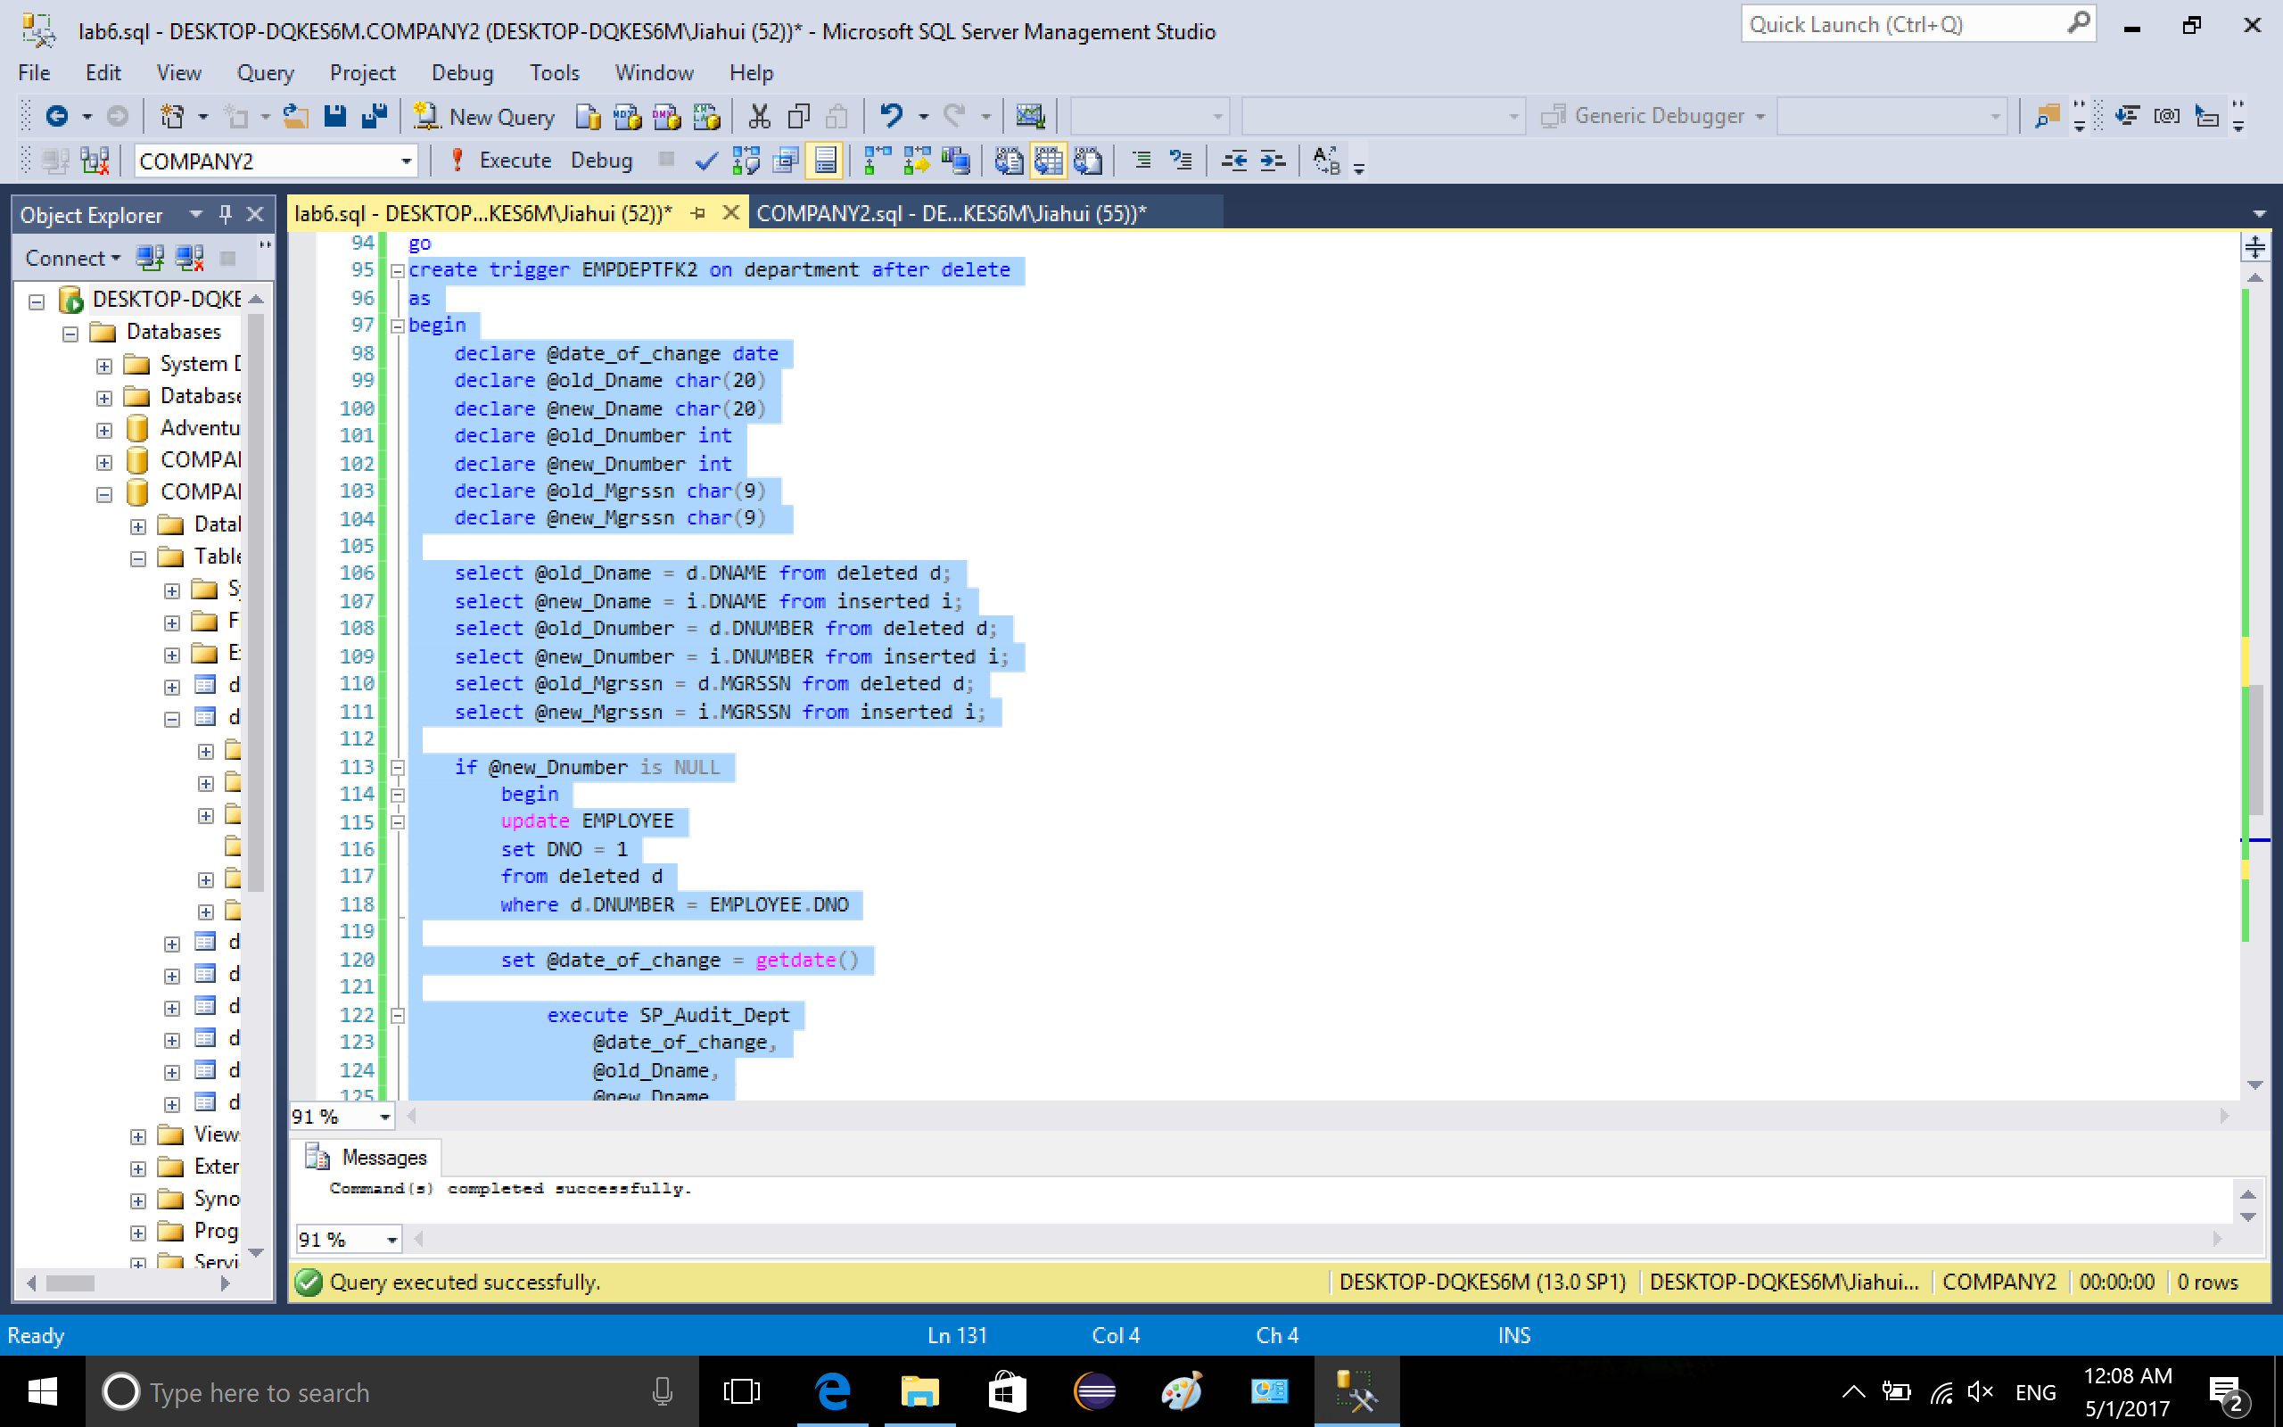

4-2. tables before deleting, which are the same as the tables after updating in 3-4.

Audit\_Dept\_Table

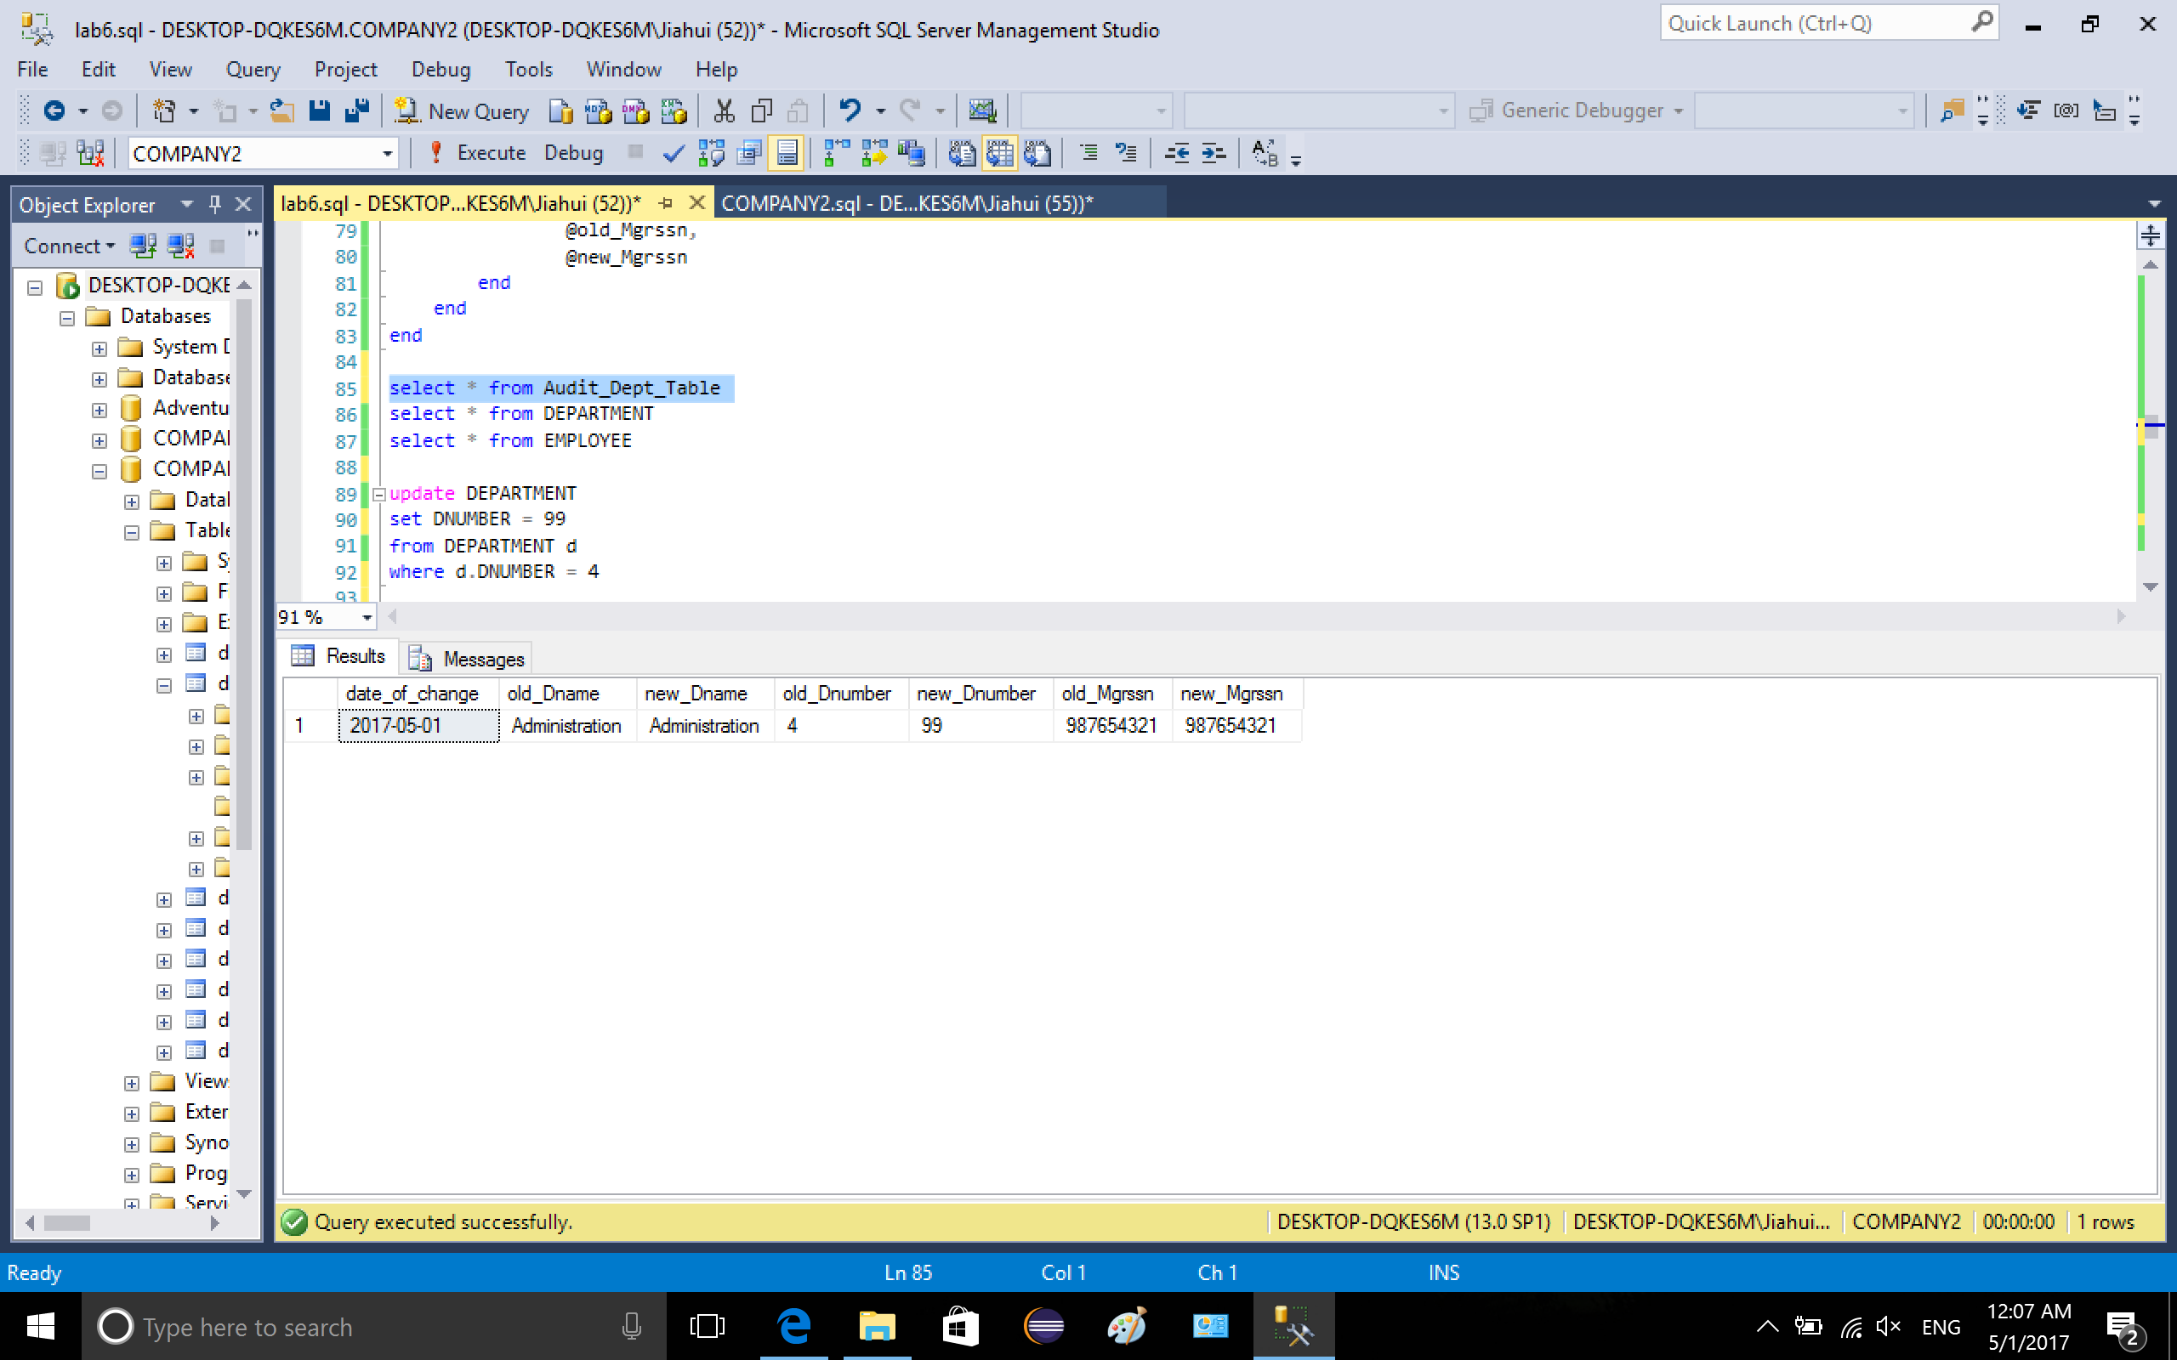

table department

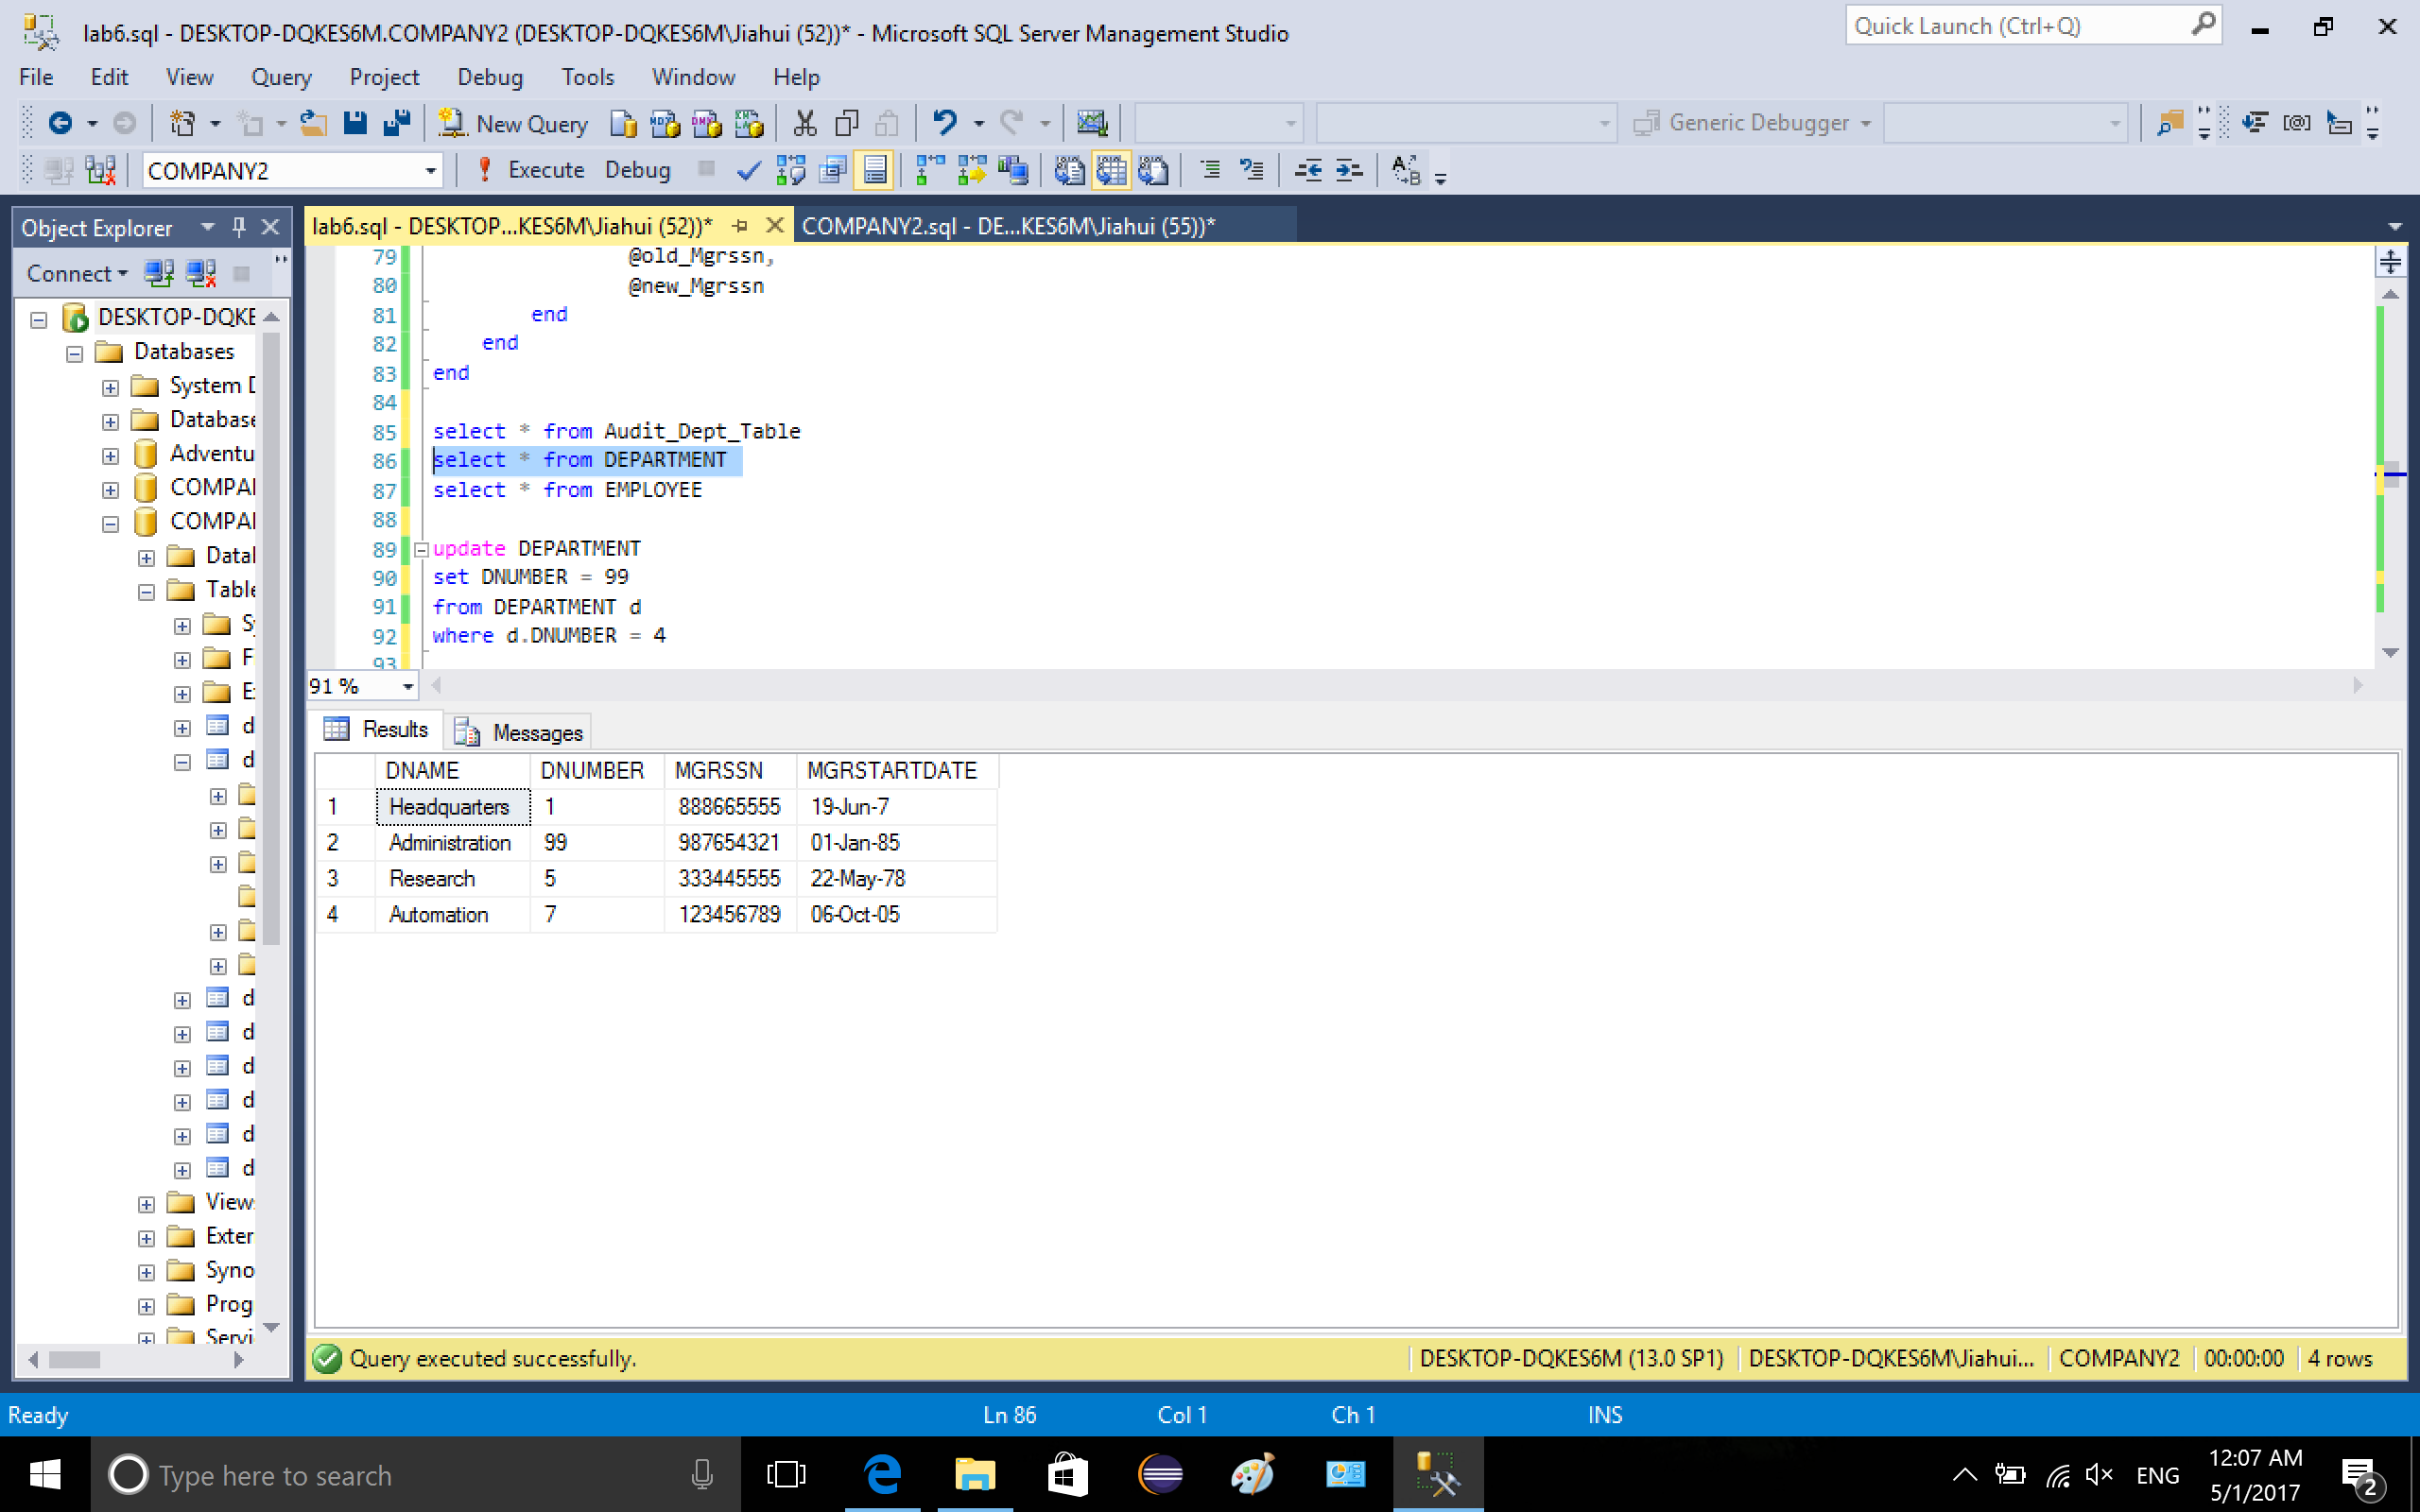

table employee

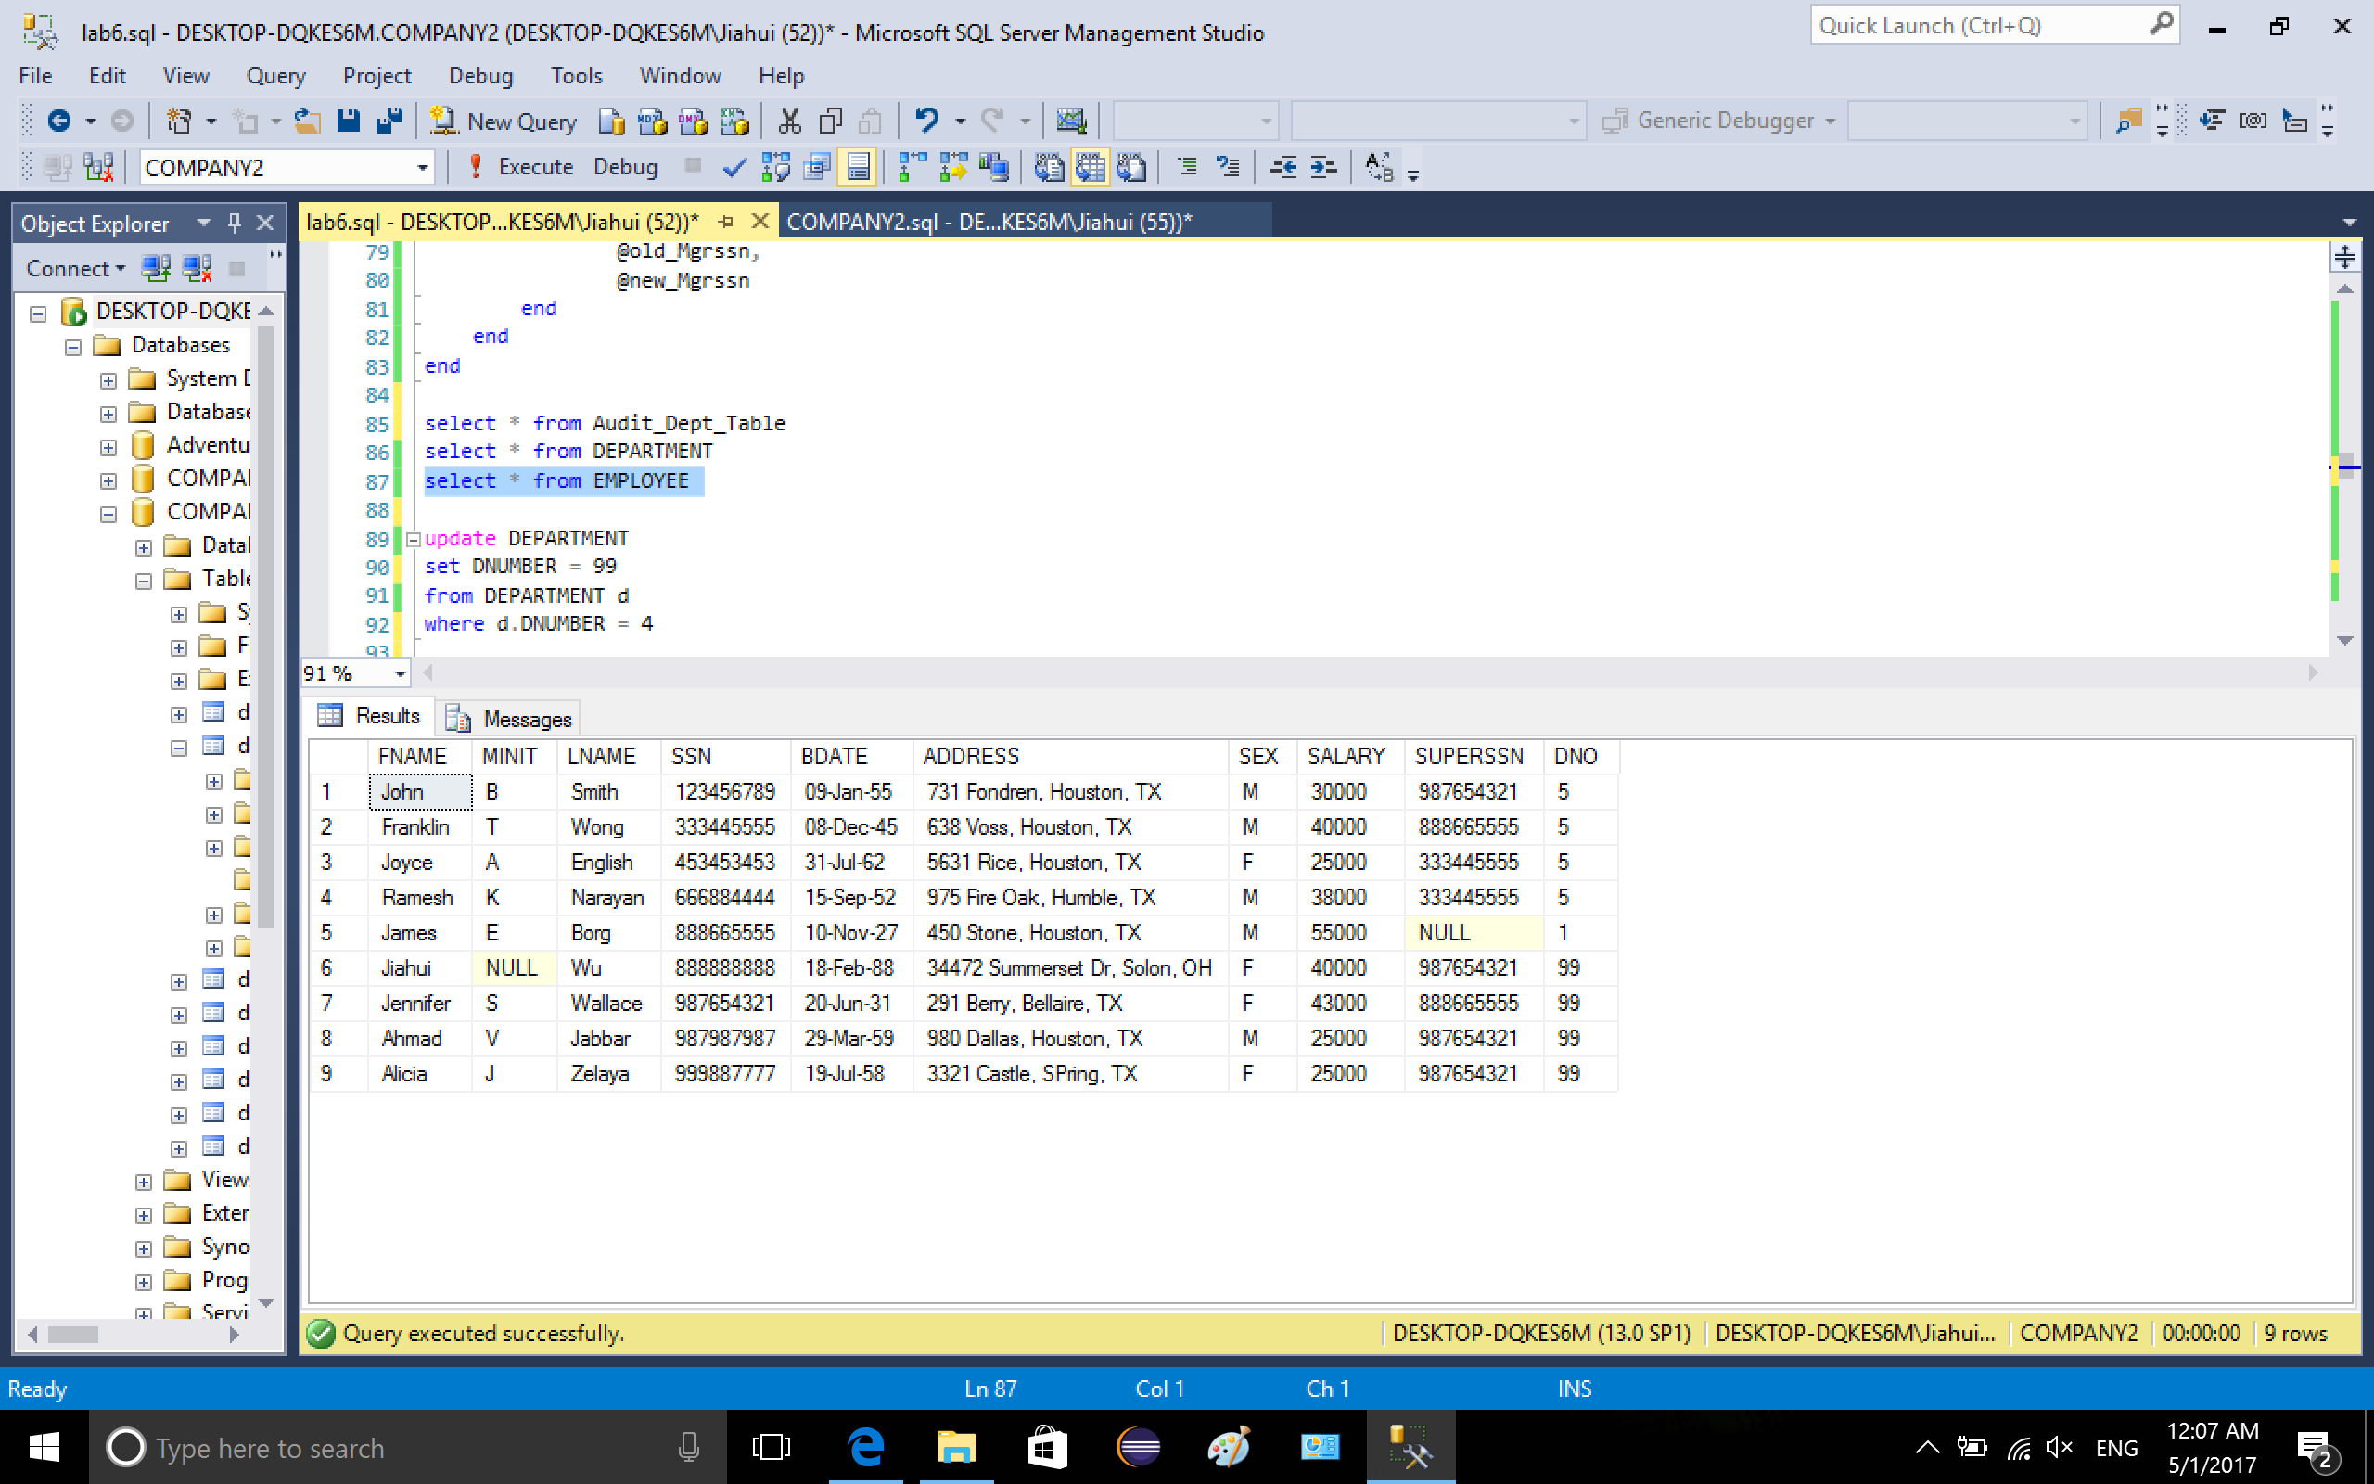

4-3. delete from table department where Dnumber is 5

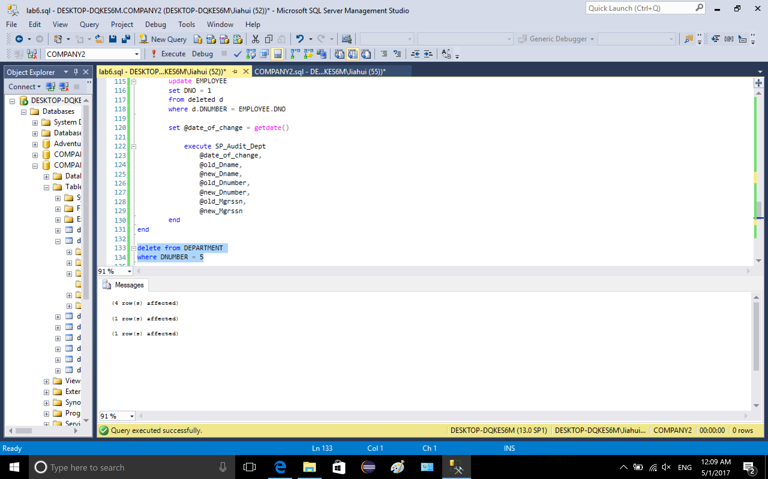

4-4. The three tables after deleting

Audit\_Dept\_Table (explanation is in the following picture)

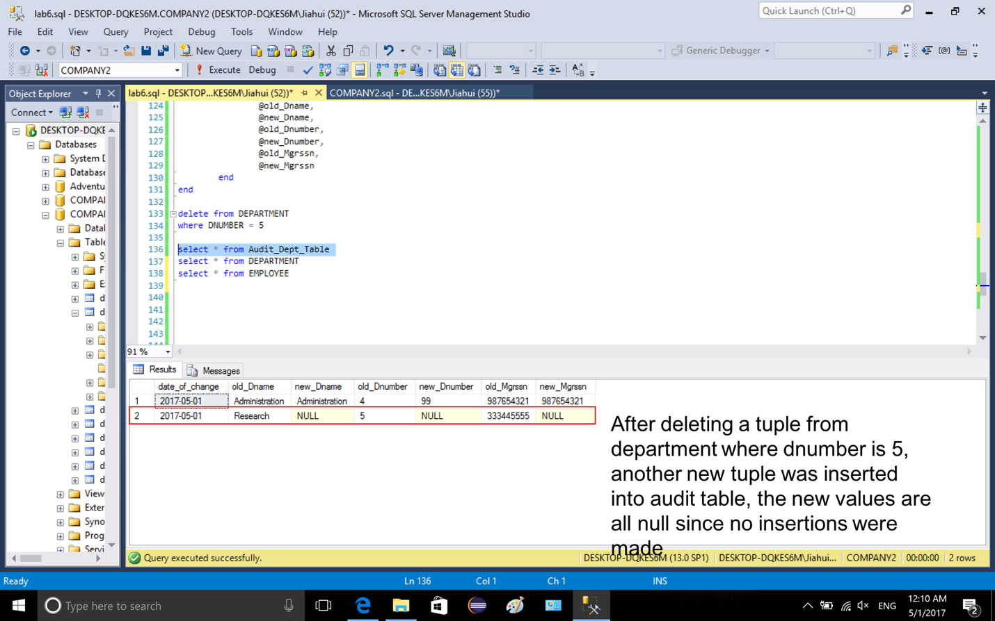

table Department (explanation is in the following picture)

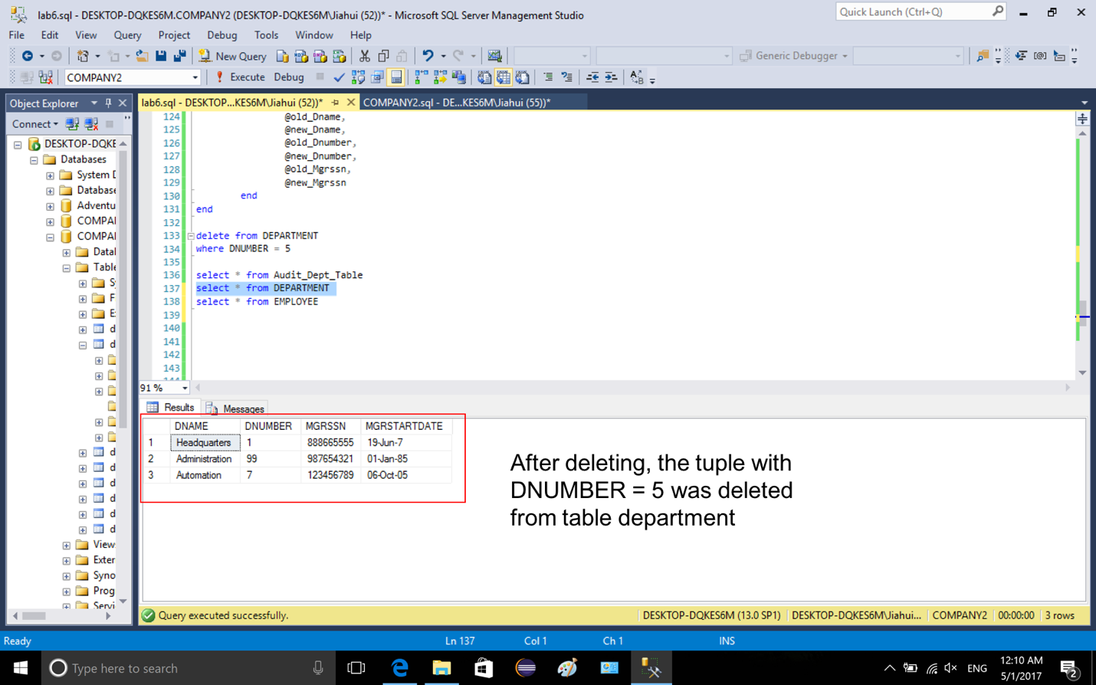

table employee (explanation is in the following picture)

